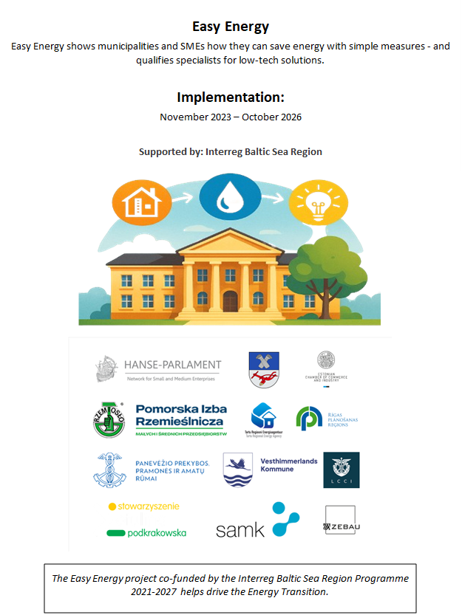
Collection of Blueprints

Many public buildings and especially micro and small businesses in the BSR have not yet implemented any energy efficiency measures. In part, this is because the energy consultings or audits offered are costly and time-consuming, and end up suggesting technical measures that, while extremely useful, take many years to pay off. Municipalities, with their large number of buildings, and small and medium-sized enterprises (SMEs) have limited to no financial reserves to invest in this area. This is particularly true for rural areas which can still make a significant contribution to solution development, piloting and transfer. As the EU RePower Directive adopted in December 2022 notes, there is savings potential in low-tech solutions and behavioural change. Easy solutions that can be implemented quickly without high investments are needed.

The following “collection of blueprints” presents a selection of 12 solutions on the topic of "Building Insulation and Energy Saving" and 11 solutions on "Heating, Electricity and Water."
The selection was made in a multi-stage process involving the 12 partner organizations of the "Easy Energy" project. In a first step, all project partners compiled a collection of possible measures and implementation examples. These were reviewed by the lead partner, the Hanseatic Parliament, and the project partner ZEBAU, and preselected for further discussion. The final selection was made by the project partners, Vesthimmerlands Municipality (Denmark) for the area of "Building Insulation and Energy Saving" and Tartu Regional Energy Agency (Estonia) for the area of "Heating, Electricity and Water."
The criteria for the selection were that the solutions could be implemented as quickly as possible and without high investment costs. The discussion and selection were based on research, typical results from completed example projects, and the project partners' own evaluations and experiences.
Particularly in "Building Insulation and Energy Saving," the goal was to define the comparatively simplest solution for each area of the building envelope, even if this appears relatively cost-intensive compared to all other measures.

The information on implementation periods, investment costs, and profitability was provided in categories and ranges. The implementation period can be broken down into the time for internal discussion and the decision to implement the measure, the planning phase, and the actual implementation. Therefore, the total time until the actual implementation of the measure can vary considerably. Especially decision-making processes within municipal administrations can delay implementation.
The absolute investment costs differ according to the size of the building and the scope of the measure. Therefore, the costs were defined according to building component areas or individual components if possible.
Especially information on the cost-effectiveness of individual measures depends on the specific project conditions, the technical implementation, the proportion of DIY by in-house personnel, nationally varying investment costs, and avoided energy costs. Therefore, this information will be evaluated during the implementation of the solutions and considered in the development of the final national collection of blueprints.
In addition, an individual life cycle cost analysis must be carried out for each situation.
Another relevant aspect is the nationally or regionally specific and regularly changing funding opportunities. Therefore, at the beginning of any planning process, an examination of possible funding and its administrative and technical conditions, as well as the possibilities for other support, should be considered.
Often, the granting of subsidies is tied to the implementation of the measures by specialist companies or further measures for quality assurance and monitoring, so that do-it-yourself contributions are limited or even completely impossible in those cases.

Table of Content
Building Insulation and Energy Saving 4
Top floor ceiling insulation 5
Insulation of basement ceiling 10
Blown-In insulation roofs and wooden walls 16
Blown-In insulation masonry walls 20
Brickwork in radiator niche 24
Insulation or reflective mat behind radiator 28
Insulation film for windows 33
Reglazing 38
Window replacement 41
Insulating blinds and shutters 45
Door closer 49
Pipe insulation 53
Heating, Electricity and Water 58
Hydronic balancing 59
Heat load management/Smart temperature control 63
Smart thermostats 66
Temperature control by app 70
Visualization of energy consumption/ Energy monitoring 73
Lighting adaptation 77
Efficient lighting / LED lighting 80
Lighting control 83
Socket timer/ digital socket plug 87
Aerator for water faucet 90
Sensor water faucet 93

Building Insulation and Energy Saving
- Top floor ceiling insulation
- Insulation of basement ceiling
- Blown-In insulation roofs and wooden walls
- Blown-In insulation masonry walls
- Brickwork in radiator niche
- Insulation or reflective mat behind radiator
- Insulation film for windows
- Reglazing
- Window replacement
- Insulating blinds and shutters
- Door closer
- Pipe insulation

Top floor ceiling insulation
Brief description
Uninsulated top floors account for up to 10-20 % of a building's total heat loss. Even if the building walls are well insulated, a lot of heat can escape through the upper building envelope. To reduce this heat loss, if the attic is to remain unheated, the top floor ceiling can be relatively easily insulated using various measures.
Floor insulation is usually achieved either by blowing or inserting insulating material between the joists or by applying insulating material to the floor surface. It is important to plan for and incorporate protective barriers, to keep steam/water out of the insulation. Sustainable materials like wood wool, cellulose or (less recyclable) mineral wool are preferred over plastic-based insulation. The use of foams should be avoided, as they behave differently than wood structures when exposed to temperature changes and can therefore lead to damage.
Insulation boards on the floor ceiling secure a certain stability. If the room should be used as living space, the floor insulation must be covered by an additional layer such as wooden boards to ensure the capability and load capacity. Additional costs may apply to attics with storage rooms, steps, doors and built-in features.
#insulation #buildingenvelope #coldprotection #heatprotection #thermalbridges

Thematic allocation |  | Building categories
☒ Insulation | ☐ Electricity production | ☐ Administrative | ☐ Educational or social institution
☐ Energy/heating system | ☐ Lighting | ☐ Commercial | ☐ Residential housing
☐ Water heating supply | ☐ | ☐ Industrial construction | ☒ All building types

Implementation time | Saving potential
☐ Quick to implement (within a few days) | ☒ Energy | ☒ Costs
☒ Short term (within 12 weeks) | ☒ CO₂ | up to 10 - 20 % energy-savings
☐ Medium term (within 6 months) | ☒ Other positive Effect: | Higher thermal comfort
☐ Long term (longer than 12 months)

Orientation | Priority level | Qualification level | Special safety
☐ Behaviour | ☐ Low | ☒ DIY / own work | ☒ Not necessary
☐ Technical | ☐ Medium | ☒ Specialist company | ☐ Advisable
☒ Construction | ☒ High | ☐ Expert | ☐ Mandatory

Implementation requirements
Investment costs | Return of investment
Simple construction: around 75 €/m²  Walkable construction: 100-150 €/m² | Return of investment within a few years.
Possible subsidies and programs | Availability of the material or technology
Example for Germany  KfW program Nr. 152 for individual measures | The materials are generally available in hardware stores.
Special requirements, safety precautions, challenges or conditions
It is advisable to use recycled materials or natural insulation, such as wood wool, cellulose, mineral / rock wool. Mineral wool is “relatively sustainable,” but usually disposed of in construction waste landfills and is therefore only recyclable in exceptional cases.
Fire safety requirements must be considered when selecting materials (especially in public buildings). The installation of a vapor barrier must be checked, particularly when insulating between joists.
This insulation measure entails a reduction in room height. The ceiling construction should be adequately loadbearing depending on the use.

Responsibilities / Actors
Mandatory actors and required competencies
construction company / craftsmen who can install the insulation in accordance with the technical requirements, if done by a company
Voluntary / helpful actors and competencies
Energy consultant or civil engineer / architect
Possible implementation partners
---

Implementation process
First steps to initiate the measure:  preparatory actions | Installation instructions and guidelines, How to’s, open source initiatives
- Verification of funding eligibility (in some countries important before contracts are signed).  - Consultation with energy consultants/planning offices on optimization approaches.  - Planning of insulation materials and methods according to the planned use after insulation. | Example for Germany  https://redaktion.hessen-agentur.de/publication/2022/3950_2022-11-23_DIY-Anleitung-Oberste-Geschossdecke-Nicht-begehbar.pdf  https://redaktion.hessen-agentur.de/publication/2023/4121_DIY-Anleitung-Oberste-Geschossdecke-begehbar.pdf
Realization of the main part
- Preparing floor for installation, cleaning and filling in gaps, depending on construction. Removing wooden floors to fill insulation in. | 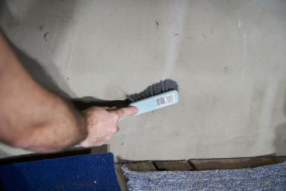  © LEA Hessen, Photo: Passivhaus Institut
- Laying out air and water-tight layer. | 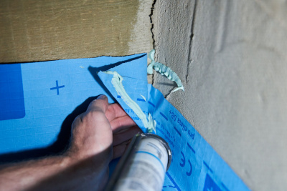  © LEA Hessen, Photo: Passivhaus Institut
- Installing insulation and fixating. | 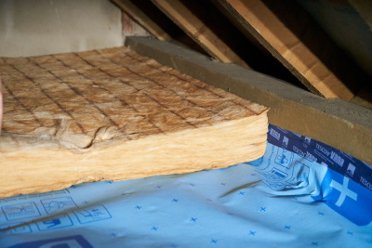  © LEA Hessen, Photo: Passivhaus Institut
- Covering up insulation with protective foil or with wood planks if walkability is required.
After installation of the measure: maintenance/operation routine | Further comments/ links
- Changed indoor climate and less permeable structure can incite mold infestations. If necessary, increasing ventilation can help.  - Monitoring consumption and evaluation of savings. | Example for Germany  https://www.schwaebisch-hall.de/ratgeber/sanieren-und-modernisieren/dach/dachboden-daemmen.html

Photos if available
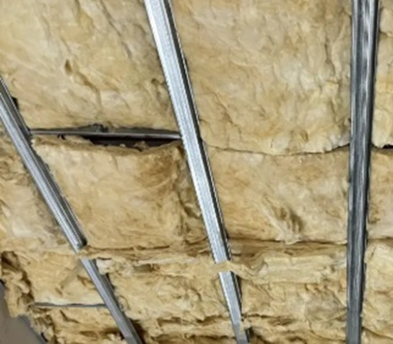
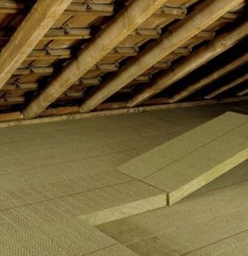
Insulation example on top floor © ZEBAU GmbH Example for a roof insulation © Karsakiskis eldership administration

Insulation of basement ceiling
Brief description
An uninsulated basement ceiling is responsible for up to 10-20% of energy losses in residential buildings. Insulating these areas is a direct energy improvement and an increase in thermal comfort for the first-floor level. The disadvantage is that the basement becomes colder, thus increasing the risk of mold growth. It is important to keep the basement as dry as possible and, if necessary, use moisture-resistant insulation. In unheated and unused basements mold is usually not a problem.
Insulating the basement ceiling begins with thoroughly cleaning the area to remove dust and dirt. Then the appropriate insulation, such as mineral wool or rock wool, is laid precisely as panels. The panels are then attached using glue or dowels to ensure stable and gap-free insulation. Finally, the insulated ceiling can be covered with a suitable surface, such as plasterboard or plaster.
The ceiling height is reduced by installing insulation panels below the ceiling. It may be necessary to adjust existing fixtures.
#Insulation #basementceiling #energyefficiency

Thematic allocation |  | Building categories
☒ Insulation | ☐ Electricity production | ☐ Administrative | ☐ Educational or social institution
☐ Energy/ heating system | ☐ Lighting | ☐ Commercial | ☐ Residential housing
☐ Warm water supply | ☐ | ☐ Industrial construction | ☒ All building types

Implementation time | Saving potential
☐ Quick to implement (within a few days) | ☒ Energy | ☒ Costs
☒ Short term (within 12 weeks) | ☒ CO₂
☒ Medium term (within 6 months) | ☒ Other positive Effect:
☐ Long term (longer than 12 months) | Increased comfort on the first floor

Orientation | Priority level | Qualification level | Special safety
☐ Behaviour | ☐ Low | ☒ DIY / own work | ☒ Not necessary
☐ Technical | ☐ Medium | ☒ Specialist company | ☐ Advisable
☒ Construction | ☒ High | ☐ Expert | ☐ Mandatory

Implementation requirements
Investment costs | Return of investment
Depending on type: (incl. labour)  - Insulation on first floor: 50-100 €/m²  - Insulation at basement ceiling: 20-50 €/m²  - Blown-in insulation in wood beam ceiling: 15-30 €/m² | Because of the low price of material and possible DIY, the return of investment of the insulation at the basement ceiling is 1-3 years.
Possible subsidies and programs | Availability of the material or technology
Example for Germany  KfW 261, but only in relation to modernization to an energy-efficient building | Available in large quantities in many places, for example in hardware stores.  Available in many variations with advantages and disadvantages in terms of ecology, price and workability available.
Special requirements, safety precautions, challenges or conditions
Ensure that valves and other important installations can be reached after the insulation installation. Fire safety regulations must be observed when working with flammable products.

Responsibilities / Actors
Mandatory actors and required competencies
---
Voluntary / helpful actors and competencies
Construction company for installation (advisable for large buildings)
Energy consultant or civil engineer / architect
Possible implementation partners
Janitor, maintenance personnel

Implementation process
First steps to initiate the measure:  preparatory actions | Installation instructions and guidelines, How to’s, open source initiatives
- Verification of funding eligibility (in some countries important before contracts are signed).  - Cleaning up the basement ceiling and preparing installments if applicable like covering up valves.  - Deciding on material and method and procuring it. | Example for Germany  https://redaktion.hessen-agentur.de/publication/2023/4101_DIY-Anleitung-Kellerdeckendaemmung-mit-EPS_2023-07-02_WF_kk_HE_kk_jms_kk.pdf
Realization of the main part
- Roughly removing any unevenness. | 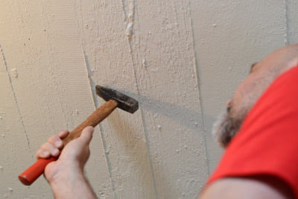  © LEA Hessen, Photo: Passivhaus Institut
- Cutting panels. | 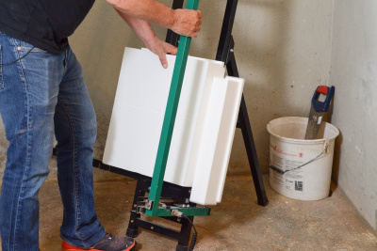  © LEA Hessen, Photo: Passivhaus Institut
- Cutouts for cables and heating pipes. | 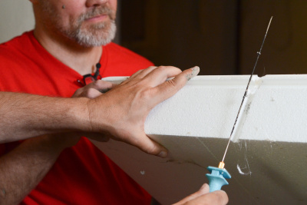  © LEA Hessen, Photo: Passivhaus Institut
- Mixing and application adhesive mortar. | 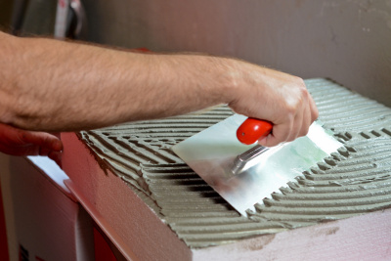  © LEA Hessen, Photo: Passivhaus Institut
- Attaching the panels. | 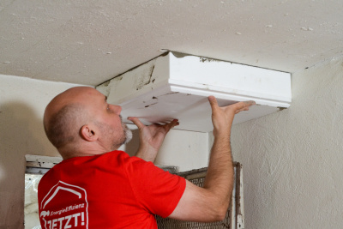  © LEA Hessen, Photo: Passivhaus Institut
- Covering heating pipes with insulation. | 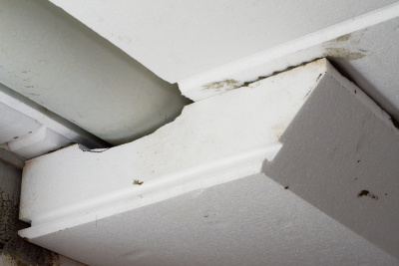  © LEA Hessen, Photo: Passivhaus Institut
- Closing gaps with assembly foam. | 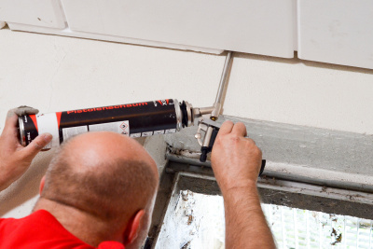  © LEA Hessen, Photo: Passivhaus Institut
- Covering or sealing insulation if necessary.
After installation of the measure: maintenance/operation routine | Further comments/ links
- Changed indoor climate and less permeable structure can incite mold infestations. If necessary, increasing ventilation can help.  - Monitoring consumption and evaluation of savings. | Example for Germany  https://www.energie-fachberater.de/daemmung/daemmung-keller/kellerdeckendaemmung/was-kostet-die-kellerdeckendaemmung.php

Photos if available
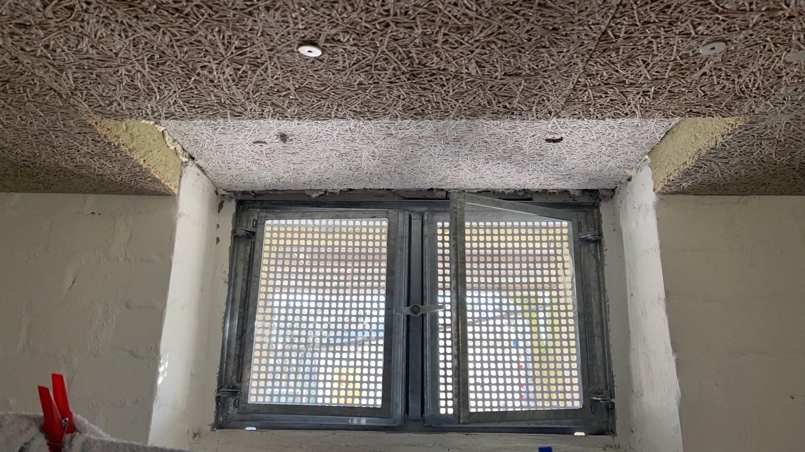 | 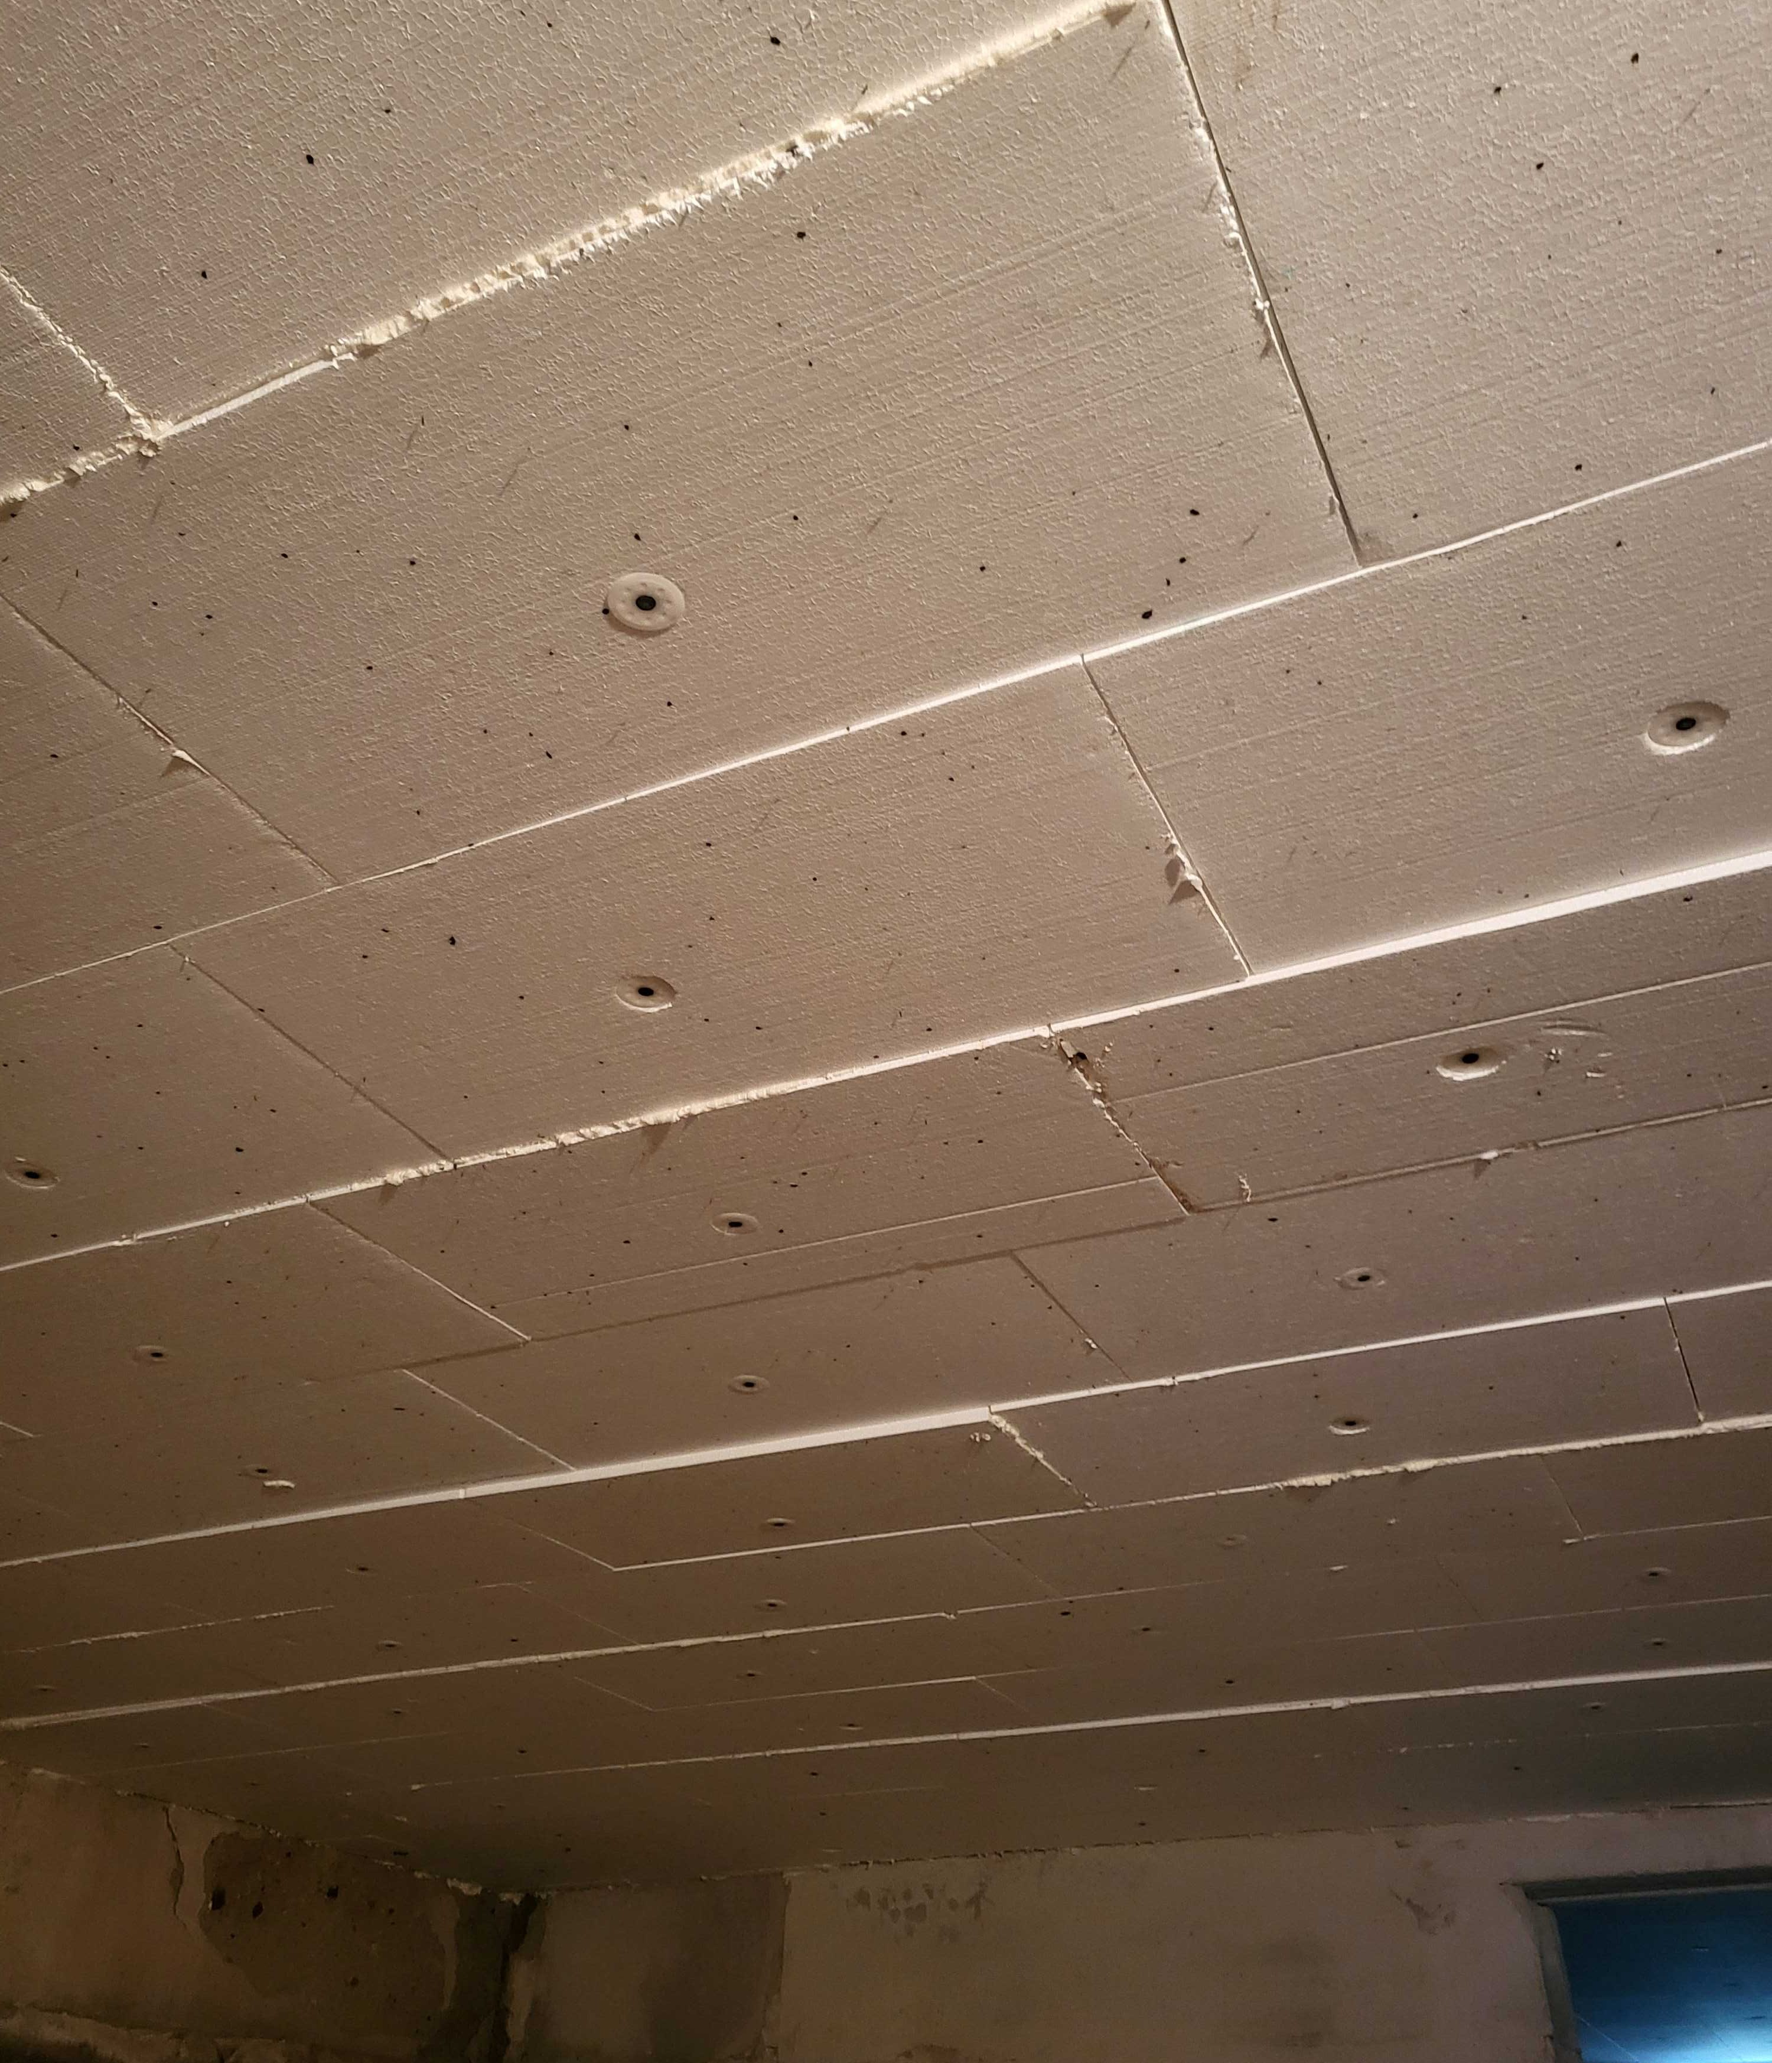
Example of insulated basement ceiling © ZEBAU GmbH | Example of insulated basement ceiling  © Pažagieniai school-kindergarten

Blown-In insulation roofs and wooden walls
Brief description
Uninsulated pitched roofs or uninsulated exterior walls made of timber frames can account for up to
40 % of a building's annual heating energy consumption. Many buildings also have roof surfaces and walls with air gaps, which are a major contributor to heat loss. Filling these air gaps with insulation enables an energy improvement without changing the thickness of the roof or the wall thickness.
Blow-in insulation made of wood wool or cellulose is a quick and efficient way to fill these existing air layers in roofs or between wall layers in timber walls. For installation, the roof surface or the wall is prepared (usually from the inside) with holes spaced approximately 30 to 40 cm apart. The insulation materials are supplied loose. The material is blown into the cavities using compressed air.
This measure can be implemented in roofs or a double-shell timber walls with an external air and vapor barrier with an air layer at least 5 cm thick.
This material is not suitable for double-shell masonry, as this can lead to moisture penetration and the material sticking together. Moisture-resistant insulation materials such as perlite are an alternative.
The use of foam should be avoided, as they behave differently than wooden structures when temperatures change and can therefore lead to damage.
#insulation #buildingenvelope #coldprotection #heatprotection #thermalbridges

Thematic allocation |  | Building categories
☒ Insulation | ☐ Electricity production | ☒ Administrative | ☒ Educational or social institution
☐ Energy/ heating system | ☐ Lighting | ☒ Commercial | ☒ Residential housing
☐ Warm water supply | ☐ | ☐ Industrial construction | ☐

Implementation time | Saving potential
☒ Quick to implement (within a few days) | ☒ Energy | ☒ Costs
☒ Short term (within 12 weeks) | ☒ CO₂
☐ Medium term (within 6 months) | ☒ Other positive Effect: | Higher thermal comfort
☐ Long term (longer than 12 months)

Orientation | Priority level | Qualification level | Special safety
☐ Behaviour | ☐ Low | ☐ DIY / own work | ☒ Not necessary
☐ Technical | ☐ Medium | ☒ Specialist company | ☐ Advisable
☒ Construction | ☒ High | ☐ Expert | ☐ Mandatory

Implementation requirements
Investment costs | Return of investment
Investment costs are 12-400 €/m² depending on the material and the required amount.  Examples: Fiberglass wool: 28 €/m³  Wood fibre: 42 €/m³  Polyurethane granulate 80 €/m³  Aerogels: 300 – 400 €/ m³ | The return of investment for the cheaper types is around 5 years.
Possible subsidies and programs | Availability of the material or technology
The measure needs to be implemented by specialized company on building insulation.
Example for Germany
Good availability in Germany
Special requirements, safety precautions, challenges or conditions
This measure can only be implemented in walls with at least 5 cm wide air spaces. The patency of the air layer should be checked beforehand by endoscopy if necessary.

Responsibilities / Actor
Mandatory actors and required competencies
construction company / craftsmen who can install the insulation in accordance with the technical requirements
Monument protection office, if necessary
Voluntary / helpful actors and competencies
Energy consultant, Architect
Possible implementation partners
---

Implementation process
First steps to initiate the measure:  preparatory actions | Installation instructions and guidelines, How to’s, open source initiatives
- Verification of funding eligibility (in some countries important before contracts are signed)
- Defining the amount needed for insulation by measuring the air layer
- Defining the best material for the project in consultation with energy expert
Realization of the main part | Accompanying communication
- Procuring installation service from a specialist company.
- Preparing roof/wall by drilling access holes
- Installing thermal insulation with special equipment.
- Closing holes
- Checking for thermal bridges
After installation of the measure: maintenance/operation routine | Further comments/ links
- Changed indoor climate and less permeable structure can incite mold infestations. If necessary, increasing ventilation can help  - Monitoring consumption and evaluation of savings | Examples for Germany  https://ekovilla.com/en/products/blownwool/  https://www.energie-experten.org/bauen-und-sanieren/daemmung/daemmstoffe  https://www.daemmen-und-sanieren.de/daemmung/einblasdaemmung/

Photos if available
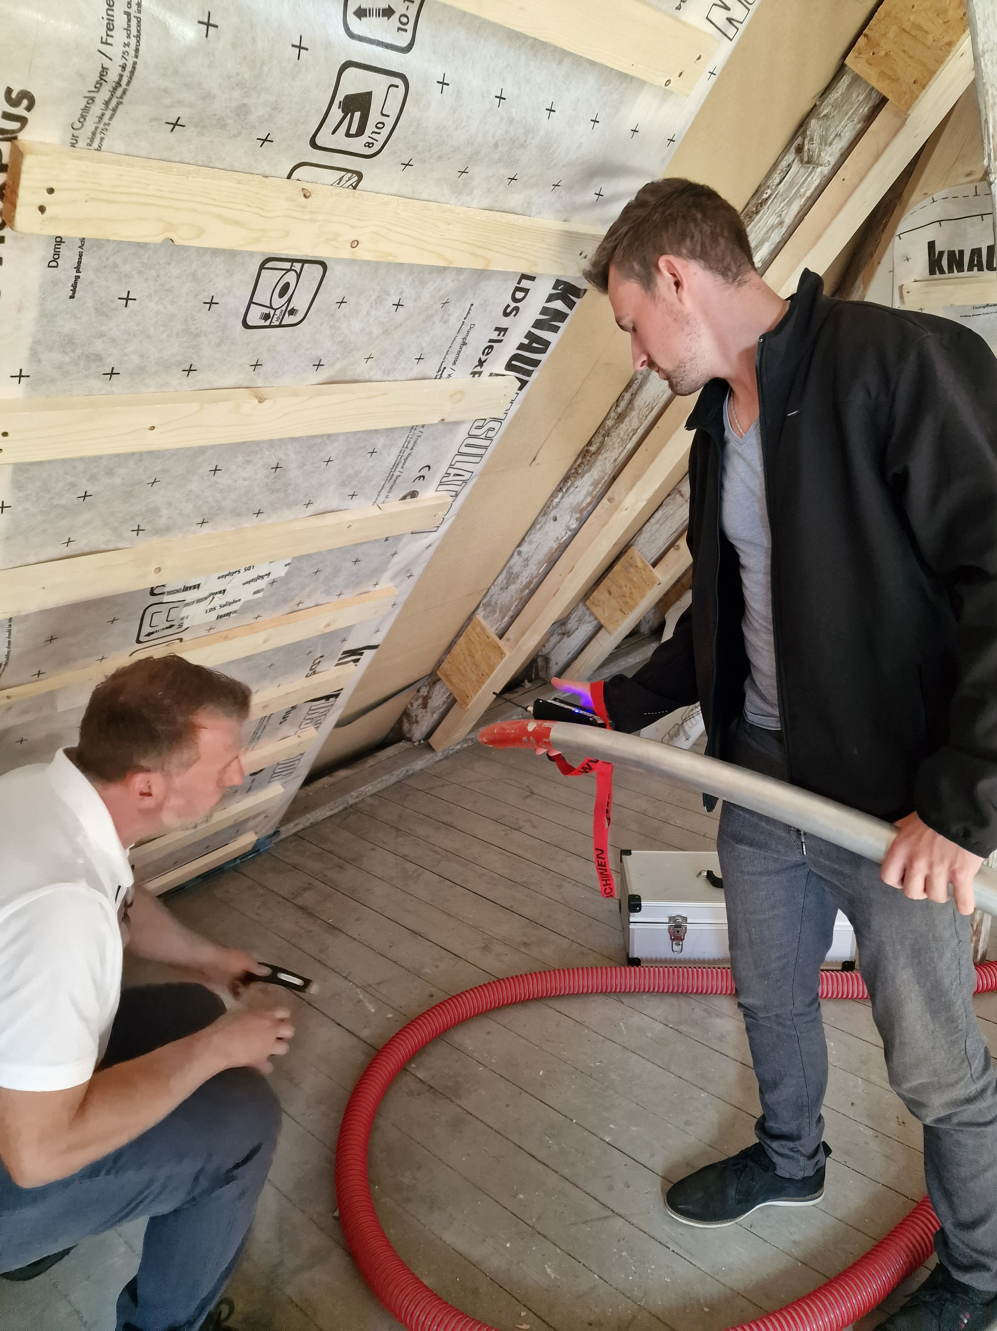
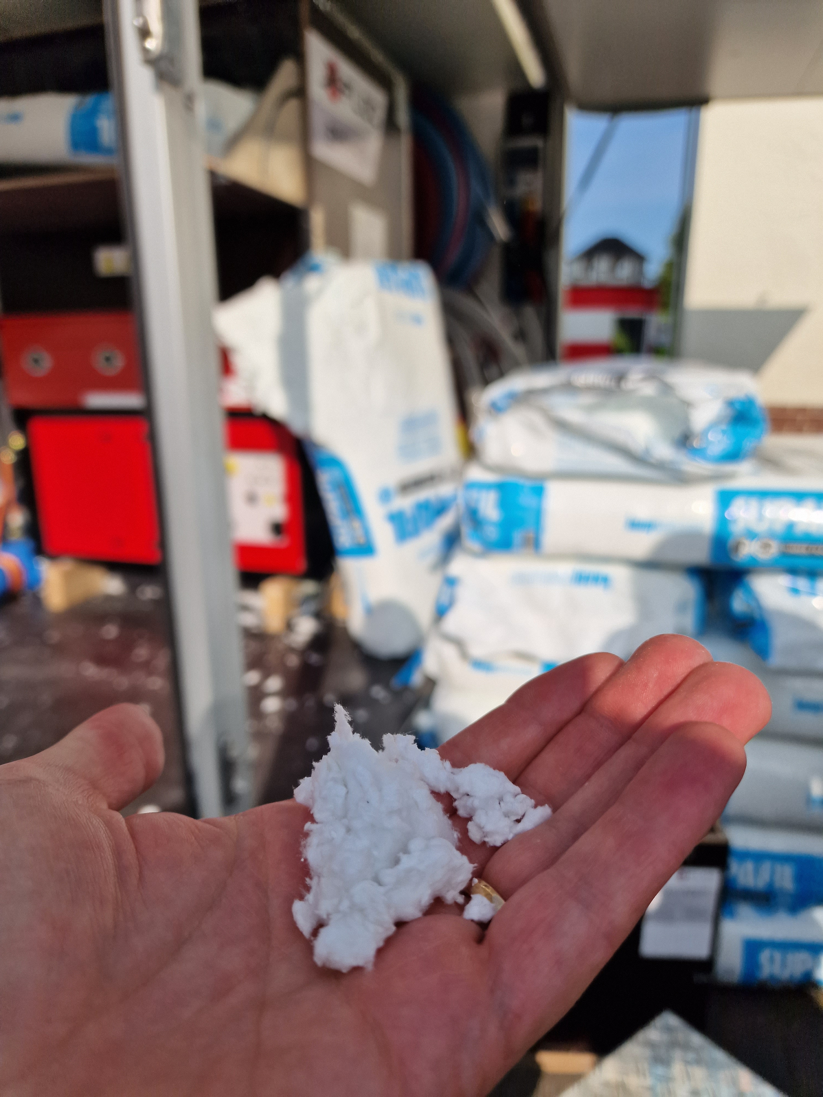
Blown In insulation installation © ZEBAU GmbH

Blown-In insulation masonry walls
Brief description
Uninsulated external walls can be responsible for up to 40 % of a building's total heat loss. Many buildings have double-shell masonry walls with air gaps, which are a major contributor to heat loss. Filling these air gaps with insulation enables energy improvement without changing the wall thickness. In addition, insulating the walls from the exterior is only effective if these air gaps are filled with thermal insulation material to build a continuous, seamless layer of insulation that eliminates cracks and cold bridges.
Blow-in insulation is a quick and efficient way to fill these existing air layers in double-shell masonry walls and can be done with Perlite, mineral fibers, Hydrophobic fiberglass flakes or polystyrene.
Perlite is fire-resistant, non-combustible, and mold-resistant, but has only moderate insulating properties. Mineral fibers offer good insulation but are sensitive to moisture. They should only be used if the facades are sufficiently sealed and not exposed to driving rain. Hydrophobic fiberglass flakes have very good insulating properties but are more expensive than traditional mineral fibers. Polystyrene also offers very good insulation but is flammable, requiring fire safety measures. Furthermore, it is petroleum-based, resulting in a poorer environmental footprint, and its removal and disposal are problematic.
For installation, the wall is prepared with holes spaced approximately 30 to 40 cm apart. The insulation materials are supplied loose. The material is blown into the cavities using compressed air.
Self-expanding polyurethane foam can be used to fill smaller cavities, e.g. wall openings, roof extensions, roller shutter boxes, etc. This method can also be used to insulate air gaps in smaller areas of walls that contain other materials — such as polystyrene granules, cotton wool, sawdust, or peat — that are either unsuitable or improperly installed. The thermal insulation foam is injected into the air gap in liquid form and transforms into a porous, solid insulation layer within a few minutes.
The use of foams for entire walls is not recommended because they can cause problems in terms of building physics, are not demountable and are also made of non-sustainable materials.
#insulation #buildingenvelope #coldprotection #heatprotection #thermalbridges #perlite #thermofoam #wallgaps

Thematic allocation |  | Building categories
☒ Insulation | ☐ Electricity production | ☐ Administrative | ☐ Educational or social institution
☐ Energy/ heating system | ☐ Lighting | ☐ Commercial | ☐ Residential housing
☐ Water heating supply | ☐ | ☐ Industrial construction | ☒ All building types

Implementation time |  |  | Saving potential
☒ Quick to implement (within a few days) |  |  | ☒ Energy |  | ☒ Costs
☒ Short term (within 12 weeks) |  |  | ☒ CO₂
☐ Medium term (within 6 months) |  |  | ☐ Other positive Effect:
☐ Long term (longer than 12 months)
Orientation | Priority level | Qualification level |  | Special safety
☐ Behaviour | ☐ Low | ☐ DIY / own work |  | ☒ Not necessary
☒ Technical | ☒ Medium | ☒ Specialist company |  | ☐ Advisable
☐ Construction | ☐ High | ☐ Expert |  | ☐ Mandatory
Implementation requirements
Investment costs | Return of investment
Mineral fiber: 60 €/m²  Perlite granulate: 75 €/m²  Expanding foams: 150 €/m² | Return of investment in 7-9 years.
Possible subsidies and programs | Availability of the material or technology
Example for Germany  KfW261, Residential building loan Efficiency house  Germany BAFA: BEG EM | Good availability
Special requirements, safety precautions, challenges or conditions
This measure can only be implemented in walls with at least 5 cm wide air spaces. The patency of the air layer should be checked beforehand by endoscopy if necessary. The much more expensive Aerogels are an option for insulation layers of less than 5 cm.
Feasible insulation method for monument protection, if holes can be done from the inside or closed with the same plaster material of the façade.
Safety training may be necessary before commercial or industrial use of self-expanding foams.

Responsibilities / Actors
Mandatory actors and required competencies
Specialized company for insulation with Perlite or thermal foam
Monument protection office, if necessary
Voluntary / helpful actors and competencies
---
Possible implementation partners
---

Implementation process
First steps to initiate the measure:  preparatory actions | Installation instructions and guidelines, How to’s, open source initiatives
- Verification of funding eligibility (in some countries important before contracts are signed).  - Assessment by specialist to determine the area of the air gap, cubic capacity, calculating the approximate cost of heating and ventilation advise. | Example for Germany  https://www.youtube.com/watch?v=07PdvcraeV8
Realization of the main part | Accompanying communication
- Procuring service from specialist company.
- Preparation for installation by drilling 16-18 mm holes in the outer walls of the house every meter. This can be done from inside for monument protection buildings.
- Injection into the space with air compressor until full.
- Sealing up holes.
After installation of the measure: maintenance/operation routine | Further comments/ links
- Changed indoor climate and less permeable structure can incite mold infestations. If necessary, increasing ventilation can help
- Monitoring consumption and evaluation of savings.

Photos if available
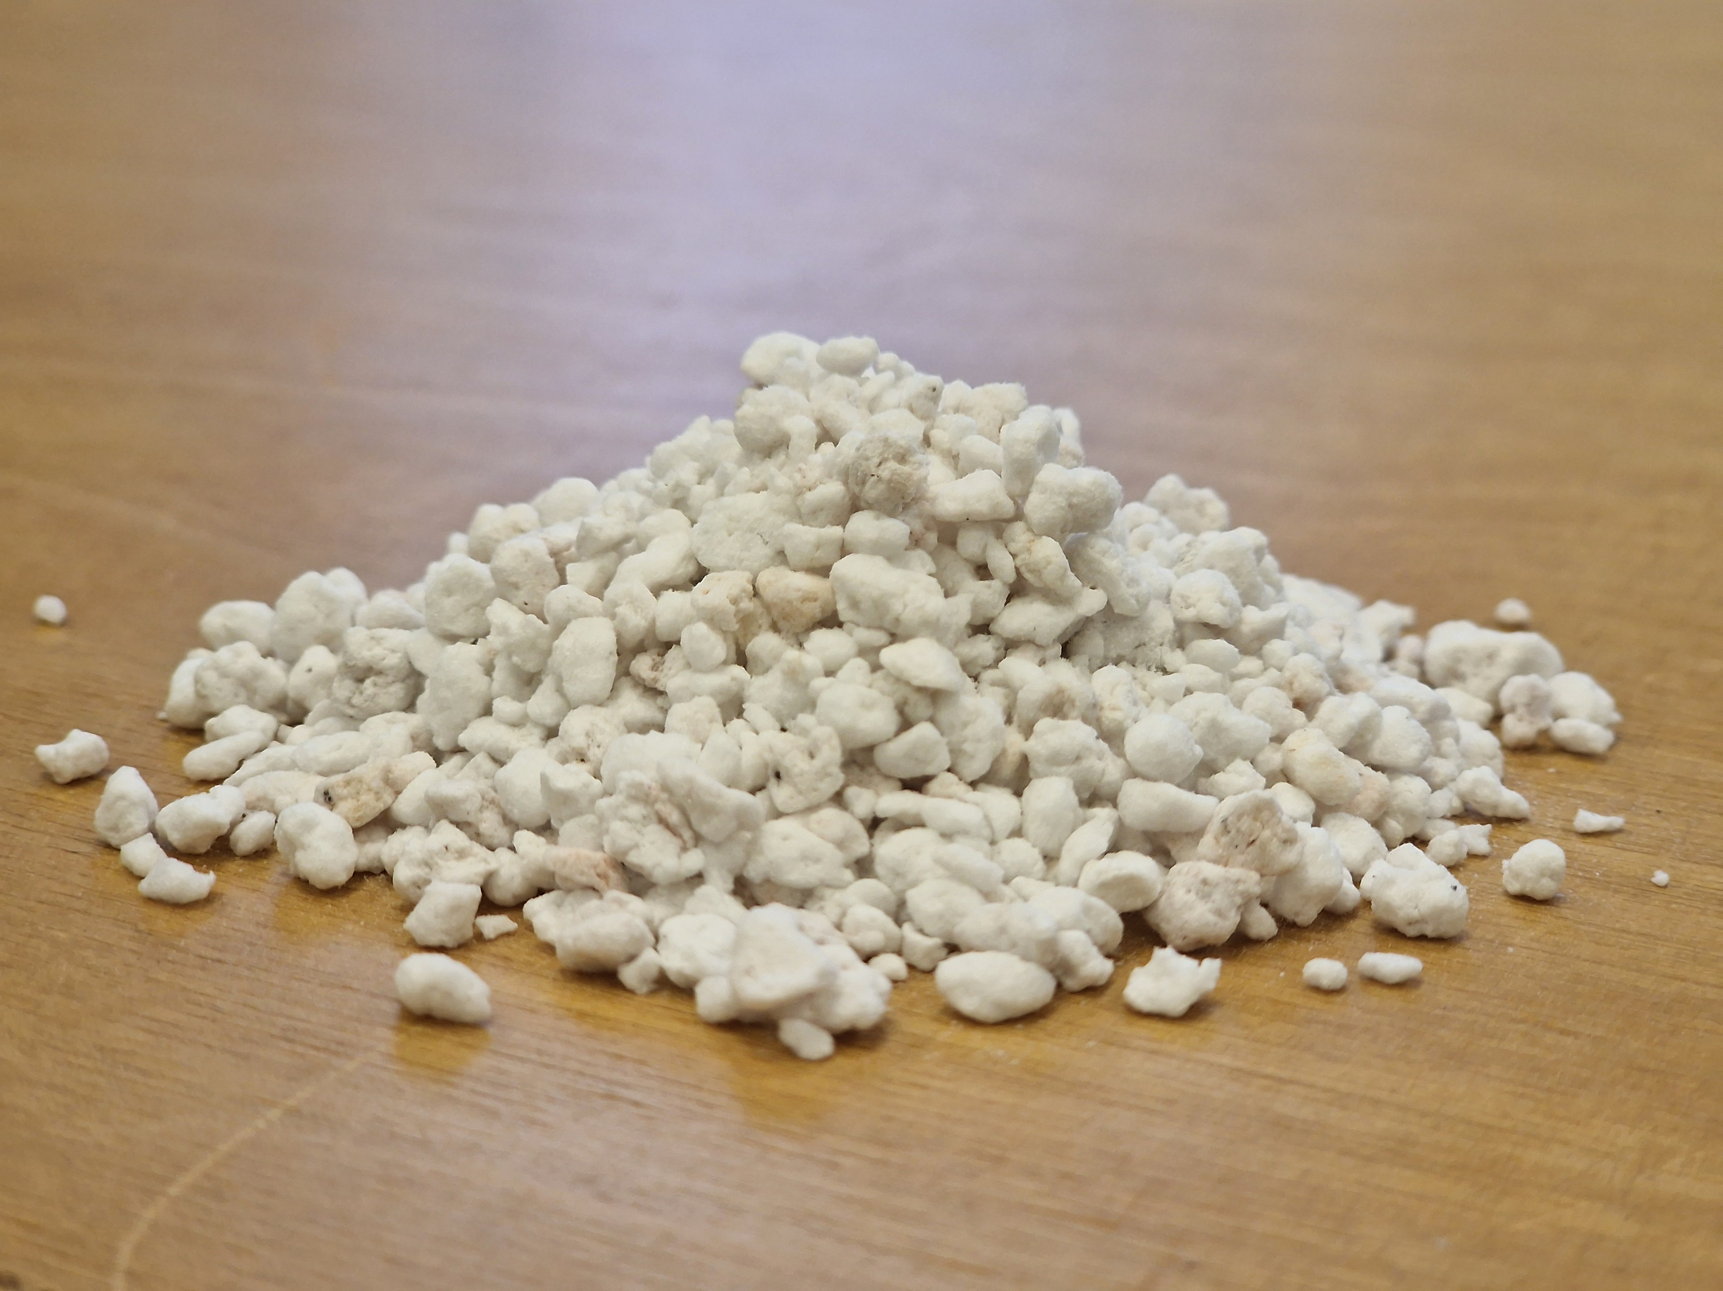
Perlite material sample © ZEBAU GmbH

Brickwork in radiator niche
Brief description
Heating niches are weak points for buildings, especially in buildings that were built earlier than 1970
Radiator niches can be bricked up to improve heating performance and increase energy efficiency. Bricking up prevents heat loss through the walls and allows for better heat distribution.
This measure is particularly suitable when replacing radiators is already planned or when converting to underfloor heating, for example, when switching to a heat pump system.
If exterior wall insulation is planned, increasing the wall thickness from the inside is unnecessary.
The process begins with removing the radiator, rerouting the heating pipes and thoroughly cleaning the niche. Suitable materials, such as bricks or insulation panels, are then fitted precisely into the niche and fixed in place with mortar or adhesives. Finally, the radiator is reinstalled on the same or in another place.
#brickwork #insulation #radiatorniche #heating

Thematic allocation |  | Building categories
☒ Insulation | ☐ Electricity production | ☒ Administrative | ☒ Educational or social institution
☐ Energy/ heating system | ☐ Lighting | ☒ Commercial | ☒ Residential housing
☐ Water heating supply | ☐ | ☐ Industrial construction | ☐

Implementation time | Saving potential
☐ Quick to implement (within a few days) | ☒ Energy | ☒ Costs
☒ Short term (within 12 weeks) | ☐ CO₂
☒ Medium term (within 6 months) | ☒ Other positive Effect:
☐ Long term (longer than 12 months) | Increase in thermal comfort

Orientation | Priority level | Qualification level | Special safety
☐ Behaviour | ☐ Low | ☐ DIY / own work | ☒ Not necessary
☐ Technical | ☒ Medium | ☒ Specialist company | ☐ Advisable
☒ Construction | ☐ High | ☐ Expert | ☐ Mandatory
Implementation requirements
Investment costs | Return of investment
Aerated concrete for lining the heating niche:  20-40 €/ m²  Removing and reinstalling heaters: 150 -200€ (without materials needed)  The costs may be higher depending on the specific conditions. | 3–7 years (depending on insulation of wall and heating behaviour)
Possible subsidies and programs | Availability of the material or technology
Example for Germany  Currently no German funding programs for this measure available. | Material available in large quantities in many places, for example in hardware stores.
Special requirements, safety precautions, challenges or conditions
When walling or insulating, it is important that the thermal conductivity is adapted to the neighbouring components to avoid mould.

Responsibilities / Actors
Mandatory actors and required competencies
Plumber to dismantle and reinstall the heating system.
Voluntary / helpful actors and competencies
Bricklayer or similar, to fill the niche.
Possible implementation partners
---

Implementation process
First steps to initiate the measure:  preparatory actions | Installation instructions and guidelines, How to’s, open source initiatives
- Considerations for other efficiency measures like window replacement or wall insulation effect planning.  - Checking whether a (partial) heating system replacement makes sense (radiator replacement, increasing radiator size or considering panel radiators).  - Recording insulation status of windows and walls.  - Removing radiators and covering valves.  - Removing floors if applicable and covering up. | Example for Germany  https://www.hornbach.de/projekte/heizkoerpernische-zumauern/
Realization of the main part | Accompanying communication
- Cleaning the walls and wetting the surface in preparation.
- Building up niche with the selected material.
- Plastering the new surface and rebuilding the heating system if applicable.
After installation of the measure: maintenance/operation routine | Further comments / links
- After installing radiators, it is advisable to carry out hydronic balancing, especially in larger buildings | Example for Germany  https://www.heizung.de/ratgeber/heizkoerper/heizkoerpernische-daemmen-darauf-ist-zu-achten.html

Photos if available
 | 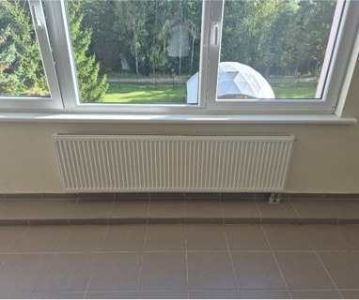
Raditator in niche © designed by Magnific (www.magnific.com) | Radiator © Dembava Progymnasium

Insulation or reflective mat behind radiator
Brief description
Radiators are usually installed along walls to keep the floor area clear for other purposes. This invites heat loss through the wall situated right behind the radiators, especially in buildings with insufficient wall insulation. A reflective film behind a radiator or insulating tiles for hanging on the back of the radiator are used to reflect heat back into the room and reduce heat loss through the wall making the radiator work more efficiently and reducing energy consumption by up to 5 %. Installation begins with cleaning the wall surface, followed by cutting the insulation mat to the appropriate size. The mat is then attached to the wall with special adhesive or double-sided tape.
This measure is most effective for old, open radiators in buildings that haven’t gone through energetic renovation.
#insulation # effective insulation #heating #insulation mat

Thematic allocation |  | Building categories
☒ Insulation | ☐ Electricity production | ☐ Administrative | ☐ Educational or social institution
☒ Energy/ heating system | ☐ Lighting | ☐ Commercial | ☐ Residential housing
☐ Warm water supply | ☐ | ☐ Industrial construction | ☒ All building types

Implementation time | Saving potential
☒ Quick to implement (within a few days) | ☒ Energy | ☒ Costs
☐ Short term (within 12 weeks) | ☐ CO₂ | up to 5 %
☐ Medium term (within 6 months) | ☐ Other positive Effect:
☐ Long term (longer than 12 months)

Orientation | Priority level | Qualification level | Special safety
☐ Behaviour | ☐ Low | ☒ DIY / own work | ☒ Not necessary
☐ Technical | ☒ Medium | ☒ Specialist company | ☐ Advisable
☒ Construction | ☐ High | ☐ Expert | ☐ Mandatory

Implementation requirements
Investment costs | Return of investment
Reflective films cost 4 €/ m²  Reflective tiles for the back of the radiator cost around 100 €/ m². | Because of the low price, the return of investment for the reflective film is under one year. Reflective tiles have a longer amortisation span but are easier to install.
Possible subsidies and programs | Availability of the material or technology
Example for Germany  Currently no German funding programs for this measure available. | Readily available in many variations and price span.
Special requirements, safety precautions, challenges or conditions
Materials can be XPS, PIR or Vacuum insulation panels, due to the very good insulation characteristics, even if the space is thin, or reflective film for very thin spaces.

Responsibilities / Actors
Mandatory actors and required competencies
This measure can be done in DIY.

Voluntary / helpful actors and competencies
---

Possible implementation partners
Janitor, maintenance personnel

Implementation process
First steps to initiate the measure:  preparatory actions | Installation instructions and guidelines, How to’s, open source initiatives
- Measuring space between radiators and walls to decide on the appropriate insulation method.  - Purchasing materials.  - Compilation of the tools and personnel required for implementation, if done as DIY. | Example for Germany  https://www.heizsparer.de/spartipps/warmedammung/heizkoerpernischen-daemmen  https://redaktion.hessen-agentur.de/publication/2022/3856_DIY-Anleitung-Heizkoerpernische_Platte.pdf  https://redaktion.hessen-agentur.de/publication/2022/3855_DIY-Anleitung-Heizkoerpernische_Daemmtapete.pdf  https://redaktion.hessen-agentur.de/publication/2022/3854_DIY-Anleitung_Heizkoerpernische-mit-Luftpolsterfolie-daemmen.pdf
Realization of the main part
- Measuring, making sketches and preparing materials. | 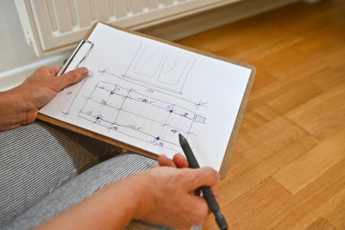  © LEA Hessen, Photo: Rundel
- Cutting the materials with recesses for the radiator mountings. | 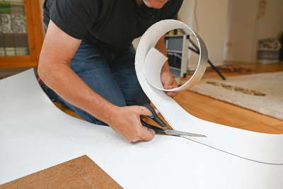  © LEA Hessen, Photo: Rundel
- Applying the first adhesive strip. |   © LEA Hessen, Photo: Rundel
- Attaching the insulation. | 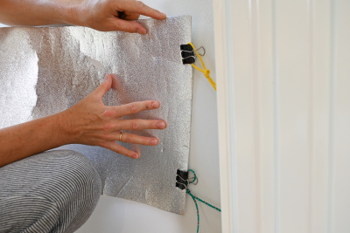  © LEA Hessen, Photo: Rundel
- Attaching the insulation and checking proper installation. | 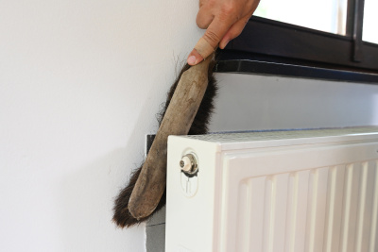  © LEA Hessen, Photo: Rundel
After installation of the measure: maintenance/operation routine | Further comments/ links
- Monitoring energy savings and adjusting heating behavior if necessary.

Photos if available
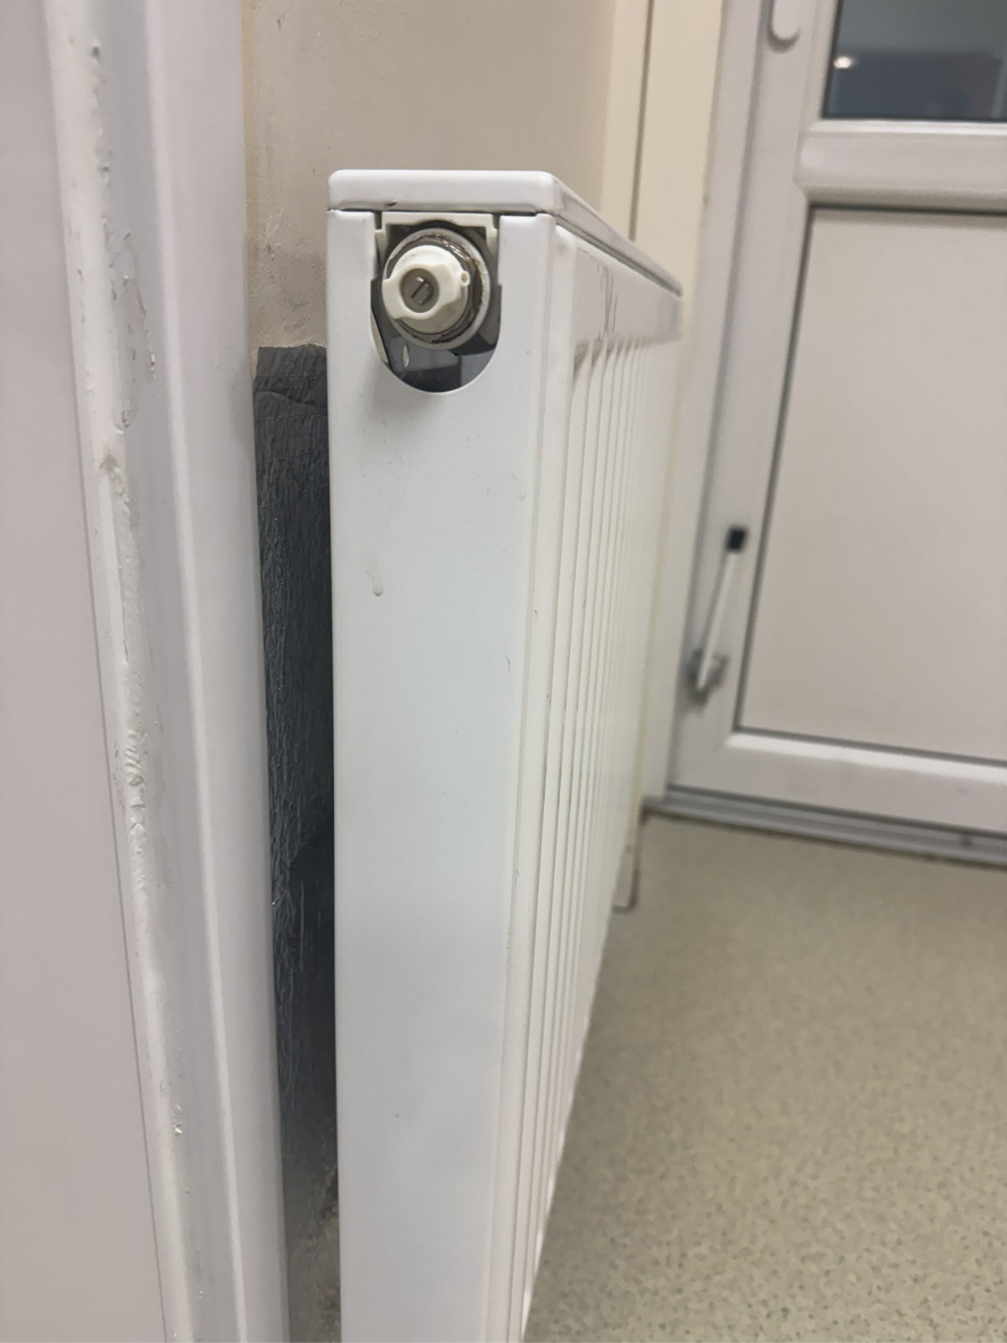
Radiator with reflective mat © Dembava nursery-kindergarten "Smalsutis"

Insulation film for windows
Brief description
Depending on their condition, windows can account for up to 25 % of a building's total heat loss.
Where a window replacement is unattainable or too expensive in the short term, a special insulation film can be applied on old single-glazing windows for heat insulation. However, this should only be considered a subordinate measure compared to replacing or reglazing windows.
The thermo-insulation film can be of two types: convection film is designed to retain heat inside, while solar control film absorbs outside heat and the UV component of outside light reflects infrared light.
Insulation films let in sunlight which can further warm a window. Any natural heat gain is beneficial as it reduces a heating system's work throughout the day.
The energy savings are generated by reducing the amount of heat lost through the glass pane window and increasing the overall insulation of the premises.
#insulation #buildingenvelope #coldprotection #heatprotection #windows

Thematic allocation |  | Building categories
☒ Insulation | ☐ Electricity production | ☐ Administrative | ☐ Educational or social institution
☐ Energy/ heating system | ☐ Lighting | ☐ Commercial | ☐ Residential housing
☐ Warm water supply | ☐ | ☐ Industrial construction | ☒ All building types

Implementation time | Saving potential
☐ Quick to implement (within a few days) | ☒ Energy | ☒ Costs
☒ Short term (within 12 weeks) | ☒ CO₂
☐ Medium term (within 6 months) | ☐ Other positive Effect:
☐ Long term (longer than 12 months)

Orientation | Priority level | Qualification level | Special safety
☐ Behaviour | ☐ Low | ☒ DIY / own work | ☒ Not necessary
☐ Technical | ☒ Medium | ☒ Specialist company | ☐ Advisable
☒ Construction | ☐ High | ☐ Expert | ☐ Mandatory
Implementation requirements
Investment costs | Return of investment
40 €/m² including installation costs through company,  20 €/m² if installed by DIY. | Return of investment in around 3 years depending on the windows and heating habits.
Possible subsidies and programs | Availability of the material or technology
Example for Germany  Currently no German funding programs for this measure available. | Available in large quantities in many places, for example in hardware stores or online.  Available in many variations with advantages and disadvantages in terms of ecology, price and workability available.
Special requirements, safety precautions, challenges or conditions
The film must be installed bubble free, which can be challenging if DIY.

Responsibilities / Actors
Mandatory actors and required competencies
---
Voluntary / helpful actors and competencies
construction company / craftsmen who can install the insulation in accordance with the technical requirements
energy consultant
Possible implementation partners
Janitor, maintenance personnel

Implementation process
First steps to initiate the measure:  preparatory actions | Installation instructions and guidelines, How to’s, open source initiatives
- Considering possible measures for thermal insulation.  - Consulting energy consultants/planning offices on optimization approaches.  - Planning insulation materials and methods. | Examples for Germany  https://www.lea-hessen.de/buergerinnen-und-buerger/hessen-spart-energie/do-it-yourself-energiesparmassnahmen/diy-energiespartipp-fensterfolien-anbringen/
Realization of the main part
- Procuring materials. | 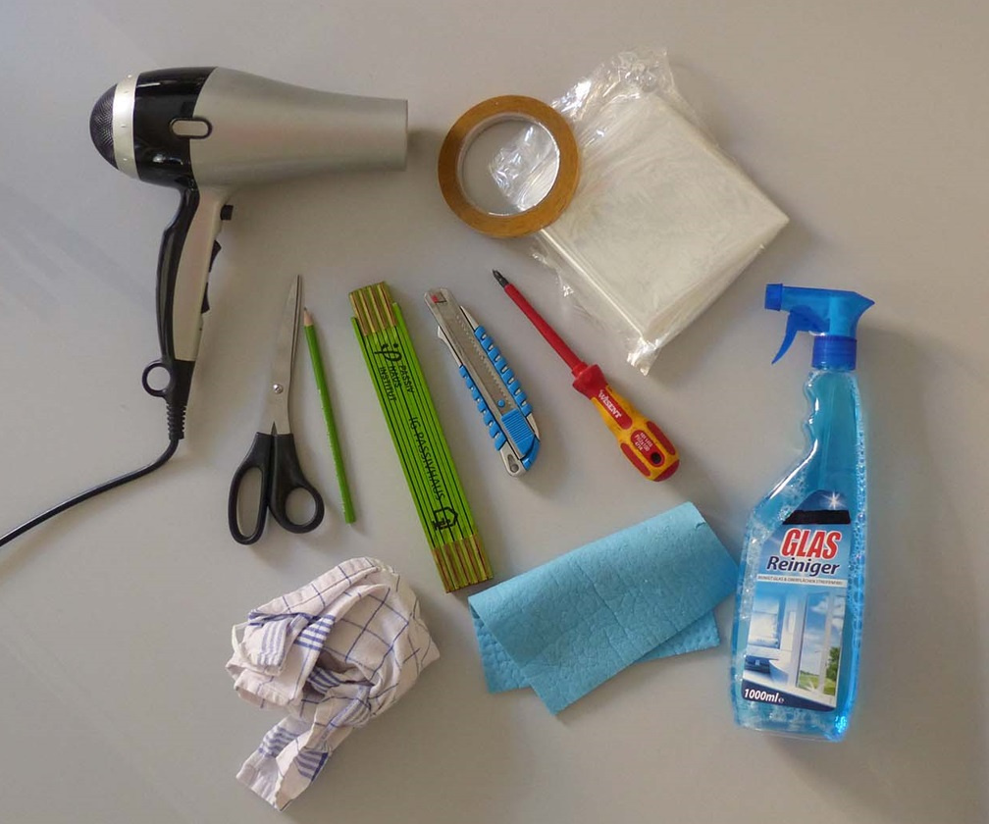  © LEA Hessen, Photo: Passivhaus Institut
- Preparing surface by cleaning. | 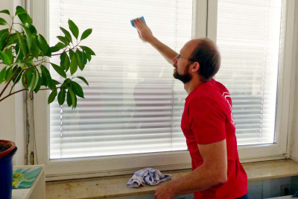  © LEA Hessen, Photo: Passivhaus Institut
- Applying adhesive tape. | 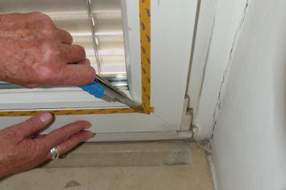  © LEA Hessen, Photo: Passivhaus Institut
- Cutting window film. | 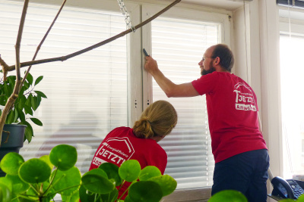  © LEA Hessen, Photo: Passivhaus Institut
- Applying the film to the window (by blow-drying) without air pockets. | 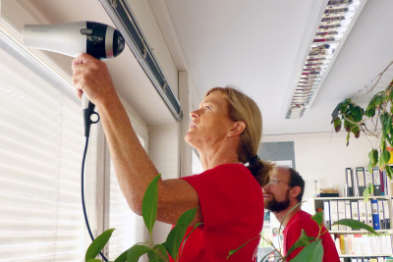  © LEA Hessen, Photo: Passivhaus Institut
- Cutting off any excess. | 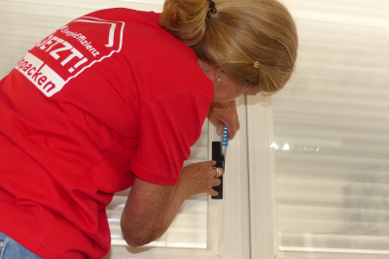  © LEA Hessen, Photo: Passivhaus Institut
After installation of the measure: maintenance/operation routine | Further comments/ links
- Monitoring consumption and evaluation of savings. | Example for Germany  https://klimaschutz-wirtschaft.de/maßnahme/waermedaemmung-von-gebaeuden-2/

Photos if available
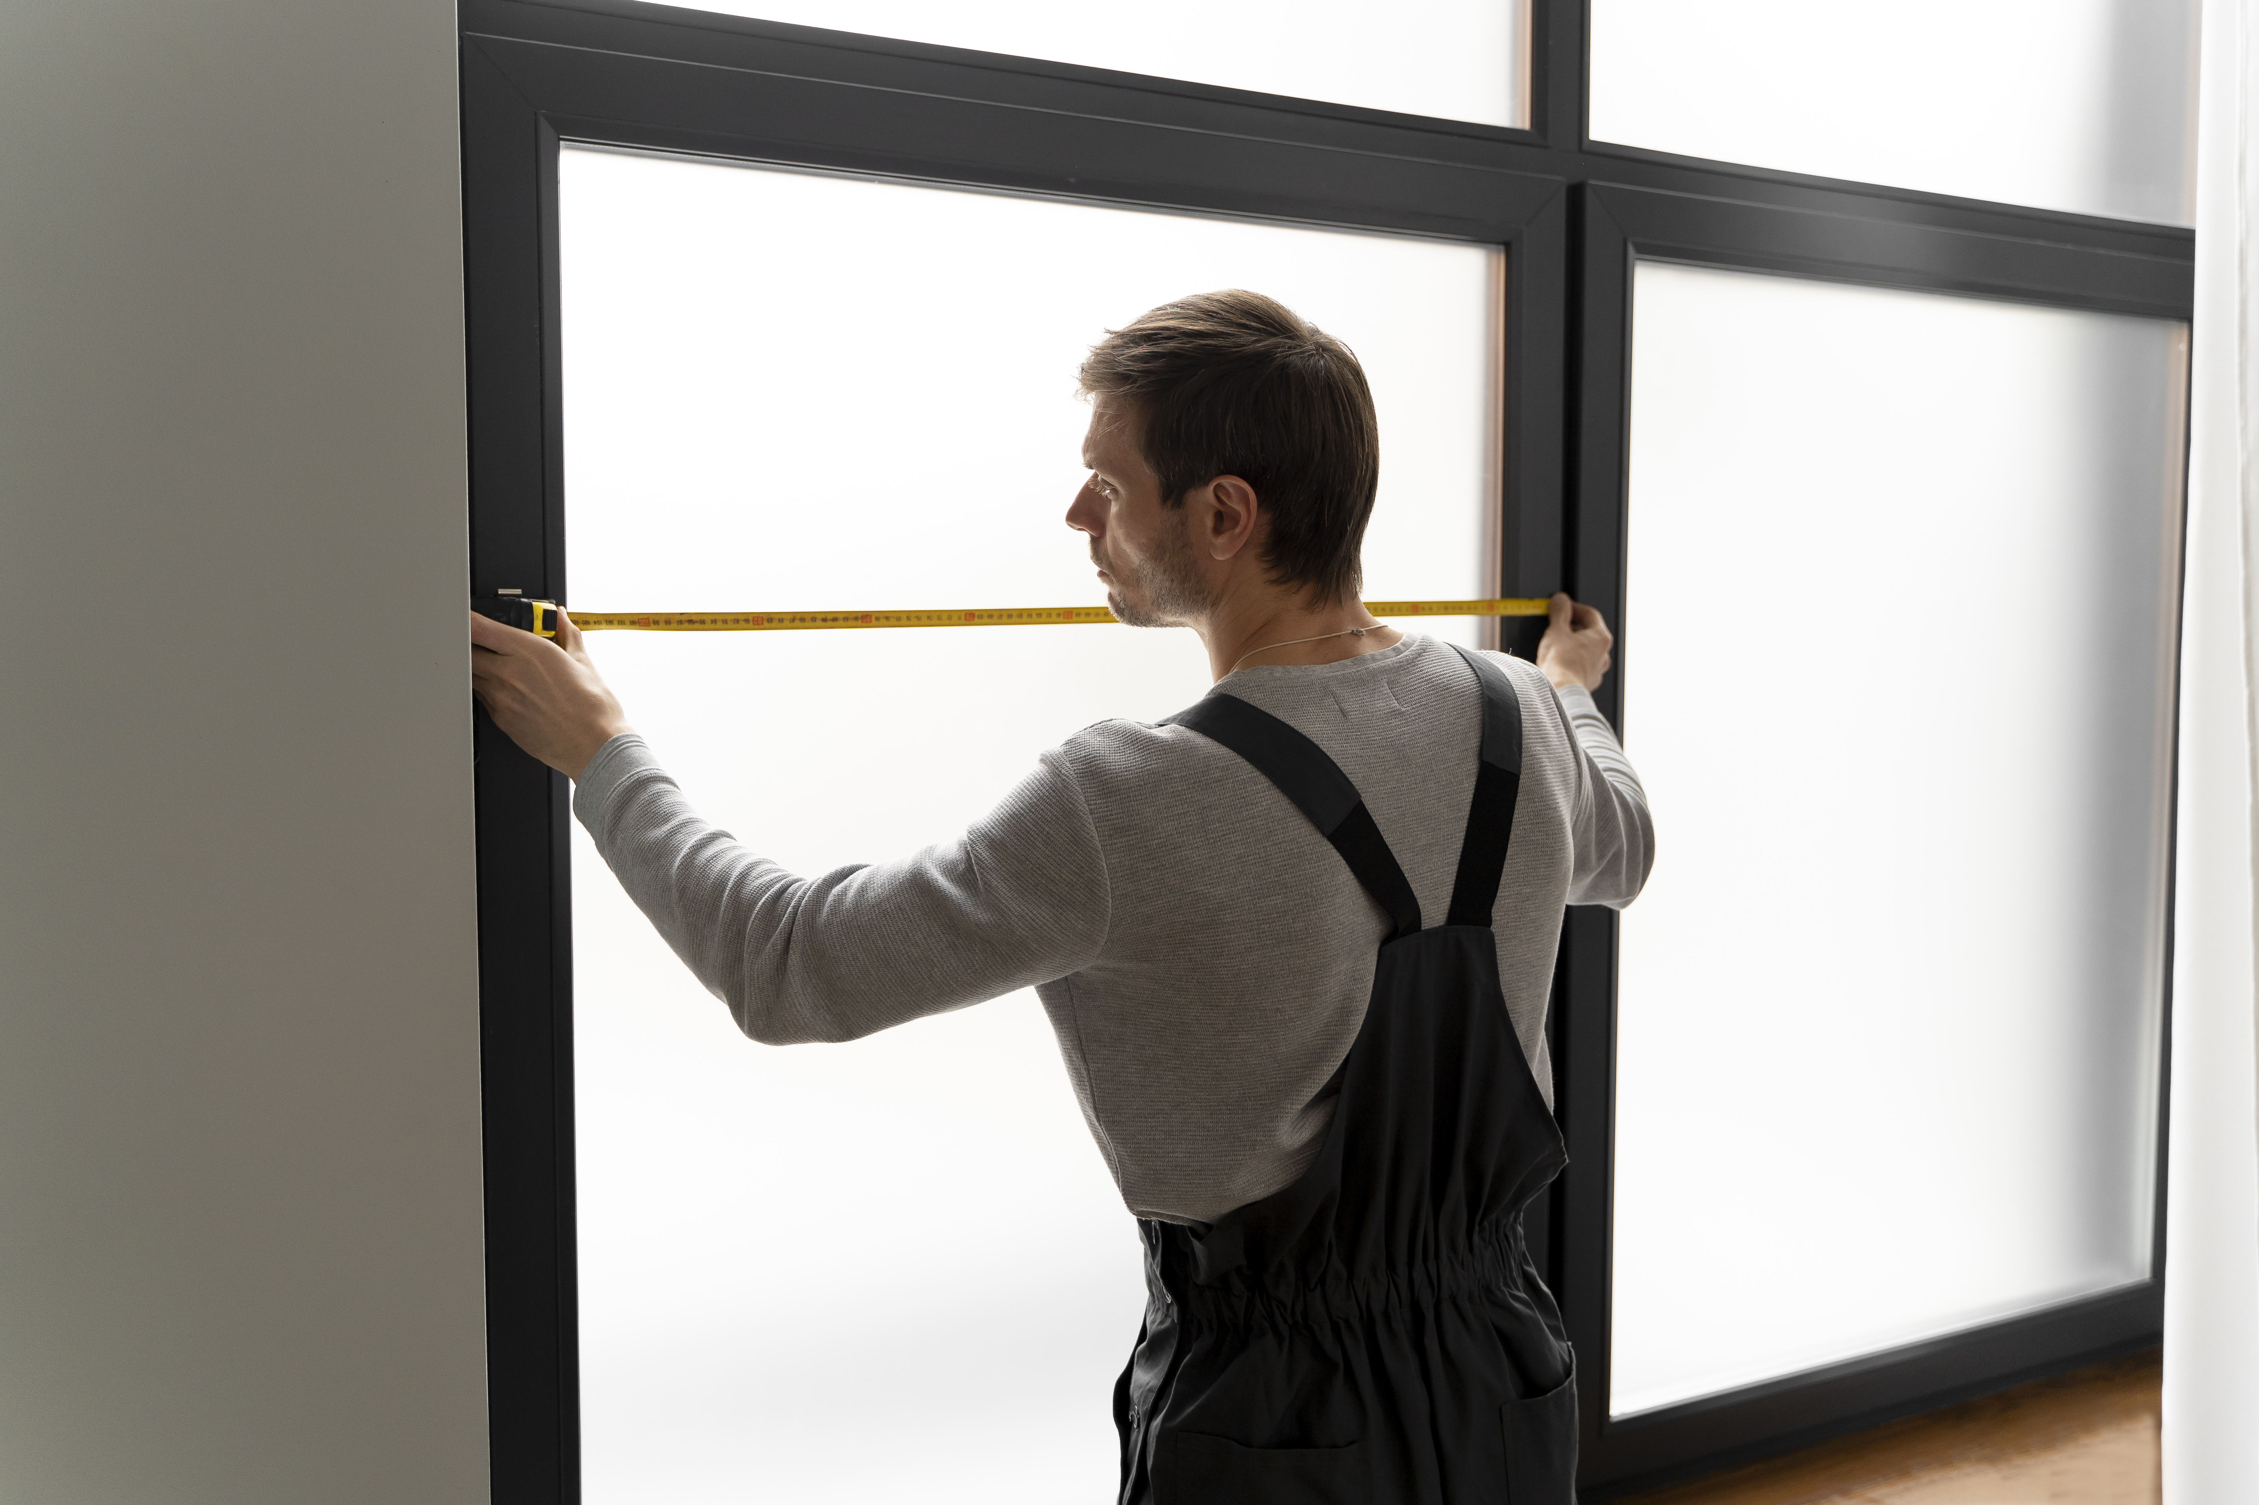
Preparation work for window film installation © designed by Magnific (www.magnific.com)

Reglazing
Brief description
Depending on their condition, windows can account for up to 25 % of a building's total heat loss.
Instead of a window replacement, old windows can be updated through a reglazing process.
This significantly increases the insulating effect and is cheaper and more sustainable, as the frames are still in use. Especially for monument preservation it can save old frames but modernize the insulation. Here, an old double-glazing unit is being replaced with a modern double-glazing unit. However, to achieve very high insulation with triple-glazing, a complete window replacement is necessary, as triple-glazing does not fit into smaller frames for double-glazing.
The process begins with the careful removal of the old window or glazing, followed by preparation of the frame. The new glass is then fitted and securely fixed, often using a special sealant to ensure air and water tightness. Restoring windows by repainting the frames is another measure that can be included in the process.

#insulation #buildingenvelope #coldprotection #heatprotection #thermalbridges
#insulationcompositesystem #exteriorinsulation #finishingsystem #eifs #etics

Thematic allocation |  | Building categories
☒ Insulation | ☐ Electricity production | ☐ Administrative | ☐ Educational or social institution
☐ Energy/ heating system | ☐ Lighting | ☐ Commercial | ☐ Residential housing
☐ Warm water supply | ☐ | ☐ Industrial construction | ☒ All building types

Implementation time | Saving potential
☐ Quick to implement (within a few days) | ☒ Energy | ☒ Costs
☒ Short term (within 12 weeks) | ☒ CO₂
☒ Medium term (within 6 months) | ☒ Other positive Effect:
☐ Long term (longer than 12 months) | Less draft in rooms

Orientation | Priority level | Qualification level | Special safety
☐ Behaviour | ☐ Low | ☐ DIY / own work | ☐ Not necessary
☐ Technical | ☐ Medium | ☒ Specialist company | ☒ Advisable
☒ Construction | ☒ High | ☐ Expert | ☐ Mandatory

Implementation requirements
Investment costs | Return of investment
Replacement double glazing: 150–300 €/m²  Dependent on frame-material around 75 € for parts | Return of investment in around 5-10 Years.
Possible subsidies and programs | Availability of the material or technology
Example for Germany  No subsidies:  Only if windows reach criteria of W/m² 0,95, which is not yet possible with double glazing. | Windows are available in large quantities.
Special requirements, safety precautions, challenges or conditions
It is a very good method to use in monument preservation, by saving old frames with new glass, but to achieve state-of-the-art insulation, window replacement with triple glazing is necessary.

Responsibilities / Actors
Mandatory actors and required competencies
Carpenter or glazier
Voluntary / helpful actors and competencies
Energy consultant or civil engineer/architect
Possible implementation partners
----

Implementation process
First steps to initiate the measure:  preparatory actions | Installation instructions and guidelines, How to’s, open source initiatives
- Deciding on the quality of the appropriate window glazing (compared to the frame and surrounding masonry).
- Calculating the materials needed.
- Find specialized company and get an offer.
Realization of the main part | Accompanying communication
- Removing windows and reglazing.
- Windows get reinstalled by window builders, according to guidelines.
- Readjusting window components.
After installation of the measure: maintenance/operation routine | Further comments/ links
- Monitoring energy consumption and evaluating savings. | Example for Germany  https://www.my-hammer.de/fenster-tueren/preisradar/was-kostet-fenster-verglasen

Photos if available
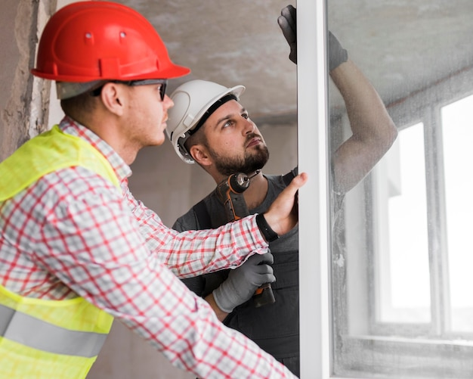
Window installation © designed by Magnific (www.magnific.com)

Window replacement
Brief description
Depending on their condition, windows can account for up to 25 % of a building's total heat loss.
Especially when windows need repairing or are simply outdated, they are no longer energy efficient and need to be replaced.
In case of modernization, it is recommended to upgrade old double glazing to new double or triple glazing. It must be ensured that the external wall after the renovation work does not have a lower insulation level than the new windows, as this would lead to mould growth.
#insulation #buildingenvelope #coldprotection #heatprotection #thermalbridges #insulationcompositesystem #exteriorinsulation #finishingsystem #eifs #etics

Thematic allocation |  | Building categories
☒ Insulation | ☐ Electricity production | ☐ Administrative | ☐ Educational or social institution
☐ Energy/ heating system | ☐ Lighting | ☐ Commercial | ☐ Residential housing
☐ Water heating supply | ☐ | ☐ Industrial construction | ☒ All building types

Implementation time | Saving potential
☐ Quick to implement (within a few days) | ☒ Energy | ☒ Costs
☐ Short term (within 12 weeks) | ☒ CO₂ | Up to 15 % of energy saving
☒ Medium term (within 6 months) | ☒ Other positive Effect:
☐ Long term (longer than 12 months) | Better comfort because of less draft

Orientation | Priority level | Qualification level | Special safety
☐ Behaviour | ☐ Low | ☐ DIY / own work | ☒ Not necessary
☐ Technical | ☐ Medium | ☒ Specialist company | ☐ Advisable
☒ Construction | ☒ High | ☐ Expert | ☐ Mandatory

Implementation requirements
Investment costs | Return of investment
Depending on quality of windows:  Double-glazing: 400 – 650 €  triple-glazing: 500 – 850 € | Return of investment in around 10 years.
Possible subsidies and programs | Availability of the material or technology
Example for Germany  BAFA and KfW subsidies | Good availability of windows
Special requirements, safety precautions, challenges or conditions
Special considerations for buildings with monument protection. Under certain circumstances, new glazing may be a sensible option to preserve the original frame.

Responsibilities / Actors
Mandatory actors and required competencies
window-company, sometimes carpenters
Voluntary / helpful actors and competencies
Energy consultant
Possible implementation partners
---

Implementation process
First steps to initiate the measure:  preparatory actions | Installation instructions and guidelines, How to’s, open source initiatives
- Verification of funding eligibility (in some countries important before contracts are signed).
- Consultation with energy experts to assess the need for replacement, i.e. damaged windows or required energy modernization.
- Check the building envelope to install suitable windows, best done with an energy concept.
- If more than 1/3 of windows are changed, there is a need ventilation concept (in Germany).
Realization of the main part | Accompanying communication
- Procuring windows and installation service from specialist company.
- Replacing windows through company by removing old windows, fitting new windows and installation.
- Paint or plaster jobs may be necessary.
- Attention must also be paid to airtightness and protection against driving rain.
After installation of the measure: maintenance/operation routine | Further comments/ links
- Regular checks on window seals and tightness of windows to maintain smooth function.  - Monitoring and evaluation of energy savings. | Example for Germany  https://wohnen-und-finanzieren.de/blog/fenster-austauschen-kosten

Photos if available
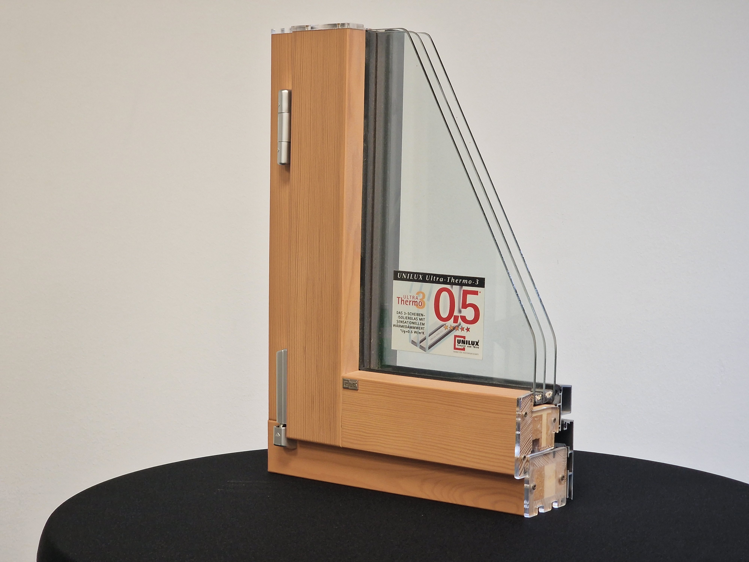
Triple glazing example © ZEBAU GmbH

Insulating blinds and shutters
Brief description
Outdated window glazing can cause up to 20-30 % of a building's heat loss. Shutters and roller shutters offer protection from sun, noise, burglary and the impact of the environment.
Roller shutters are placed outside and can be automated with sensors, timers or smart home integration. External shading produces the best effects, but internal measures can also be useful, especially in cold countries and with high wind speeds. Blinds are installed indoors and are rarely automated. Thermal curtains are made of materials like polyester, aluminium, or foil and help maintain indoor temperature by blocking heat or cold. Blinds made of insulating materials, such as wood or special plastics, provide added insulation and reducing heat loss through windows. In hot summers, blinds shield against direct sunlight, helping to keep houses cooler and reduce the reliance on air conditioning.
It is especially efficient to implement these during window replacement measures, to reduce costs for scaffolding/installation processes.
#insulation #buildingenvelope #coldprotection #heatprotection #exteriorinsulation

Thematic allocation |  | Building categories
☒ Insulation | ☐ Electricity production | ☐ Administrative | ☐ Educational or social institution
☐ Energy/ heating system | ☒ Lighting | ☐ Commercial | ☐ Residential housing
☐ Warm water supply | ☐ | ☐ Industrial construction | ☒ All building types

Implementation time | Saving potential
☒ Quick to implement (within a few days) | ☒ Energy | ☒ Costs
☒ Short term (within 12 weeks) | ☒ CO₂ | Savings from 5 – 30 %
☐ Medium term (within 6 months) | ☒ Other positive Effect:
☐ Long term (longer than 12 months) | Increased privacy and protection against burglary

Orientation | Priority level | Qualification level | Special safety
☐ Behaviour | ☐ Low | ☒ DIY / own work | ☒ Not necessary
☐ Technical | ☐ Medium | ☒ Specialist company | ☐ Advisable
☒ Construction | ☒ High | ☐ Expert | ☐ Mandatory
Implementation requirements
Investment costs | Return of investment
Shutters cost 200-300 € per piece. Additional 50 € or more for motor and automation.  Blinds cost 30 € per piece or more depending on the design and insulating effect. | 5-10 years depending on quality of windows and behaviour.
Possible subsidies and programs | Availability of the material or technology
Example for Germany  Funding available in connection with window replacements if roller shutters are automized and insulated. | Available in large quantities in many places, for example in hardware stores and online shops.  Available in many variations with advantages and disadvantages in terms of ecology, price and workability available.
Special requirements, safety precautions, challenges or conditions
When using curtains, it is important to uncover the radiators during heating periods.
Materials can be recycled if they are not painted or heavily processed.
In case of monument protection, monument protection office may need to be contacted.

Responsibilities / Actors
Mandatory actors and required competencies
---
Voluntary / helpful actors and competencies
Window company for installation, especially for large buildings.
In case of window replacement, window manufacturers for consulting and installation.
Possible implementation partners
Window manufacturers
Janitor, maintenance personnel

Implementation process
First steps to initiate the measure:  preparatory actions | Installation instructions and guidelines, How to’s, open source initiatives
- Verification of funding eligibility (in some countries important before contracts are signed).  - Decision of required measures for each window, such as burglary protection.  - Checking the building structure for durability to ensure they can carry the additional load.  - Checking the possibility of combination with other measures. | Example for Germany  https://www.t-online.de/heim-garten/wohnen/id_100077032/heizkosten-senken-mit-thermovorhaenge-und-rollos-geht-das-.html#das-ergab-unser-test  https://www.energie-umwelt.ch/saison-tipps/848-am-abend-rolllaeden-herunterlassen-bzw-fensterlaeden-schliessen
Realization of the main part | Accompanying communication
- Measuring windows to buy suitable products.
- Scaffolding might be needed and used for additional measures.
- Installation of blinds and/or shutters in DIY or through company.
- If applicable, programming of automation according to timer or sunlight sensors.
- Checking function.
After installation of the measure: maintenance/operation routine | Further comments/ links
- Monitoring of energy consumption and evaluation of savings.
- Regular inspection, especially of outdoor shutters.

Photos if available
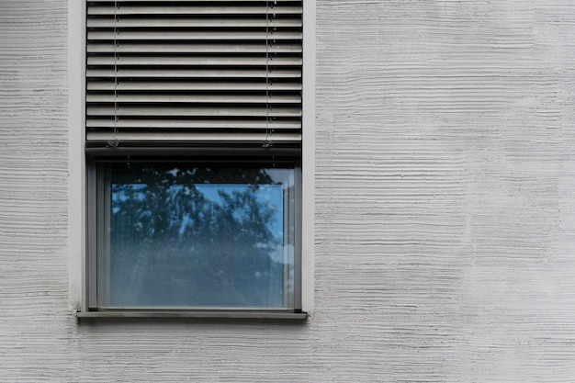
External shutter © designed by Magnific (www.magnific.com)

Door closer
Brief description
Open doors can lead to heat loss and loss of comfort, especially in buildings with different temperature zones. Automatic opening/closing of doors prevent doors to be left open, so energy can be saved. This prevents warm air from escaping the room or, in the case of air conditioning in summer, the room from heating up.
If doors between individual rooms in residential houses or flats are consistently closed, 5 % of heating costs can be saved. Cambridge University estimated for shops, that closed doors could reduce energy consumption by up to 50%.

#energysaving #doorcloser

Thematic allocation |  | Building categories
☒ Insulation | ☐ Electricity production | ☐ Administrative | ☐ Educational or social institution
☒ Energy/ heating system | ☐ Lighting | ☐ Commercial | ☐ Residential housing
☐ Warm water supply | ☐ | ☐ Industrial construction | ☒ All building types

Implementation time | Saving potential
☒ Quick to implement (within a few days) | ☒ Energy | ☒ Costs
☐ Short term (within 12 weeks) | ☐ CO₂ | up to 10 %
☐ Medium term (within 6 months) | ☒ Other positive Effect:
☐ Long term (longer than 12 months) | Increased comfort because of less draft

Orientation | Priority level | Qualification level | Special safety
☐ Behaviour | ☒ Low | ☒ DIY / own work | ☒ Not necessary
☒ Technical | ☐ Medium | ☒ Specialist company | ☐ Advisable
☐ Construction | ☐ High | ☐ Expert | ☐ Mandatory
Implementation requirements
Investment costs | Return of investment
From 30 € per unit for simple function.  Around 200 € per unit for fire doors, accessibility and other functions. | Small investment costs and a reduction in energy costs by up to 10 % on average leads to a quick return of investment.
Possible subsidies and programs | Availability of the material or technology
Example for Germany  Funding available in connection with door replacements and conversion for accessibility. | Automatic door opener/closer are readily available in stores.
Special requirements, safety precautions, challenges or conditions
Fire doors are mandated to close automatically, and doors in escape routes are mandated to open easily in the direction of the escape route.
Automatic door opener/closers must be placed in buildings other than residential, in such a way that they can be used by handicapped people as well.

Responsibilities / Actors
Mandatory actors and required competencies
---
Voluntary / helpful actors and competencies
Carpenters, window and door manufacturer
Possible implementation partners
Janitor, maintenance personnel

Implementation process
First steps to initiate the measure:  preparatory actions | Installation instructions and guidelines, How to’s, open source initiatives
- Verification of funding eligibility (in some countries important before contracts are signed).  - Choosing and procuring fitting door closers according to the requirements (fire doors, exit doors, accessibility).  - Preparation for the installation according to instructions or procuring installation service through company. | Example for Germany  https://www.youtube.com/watch?v=fVyMSnmZ_VA  https://www.youtube.com/watch?v=8SE09oKCmB8  https://www.youtube.com/watch?v=Hrinz60svi0
Realization of the main part | Accompanying communication
- Installation in DIY or through company.
- Checking if the door opens and closes smoothly.
After installation of the measure: maintenance/operation routine | Further comments/ links
- Regular control and maintenance.

Photos if available
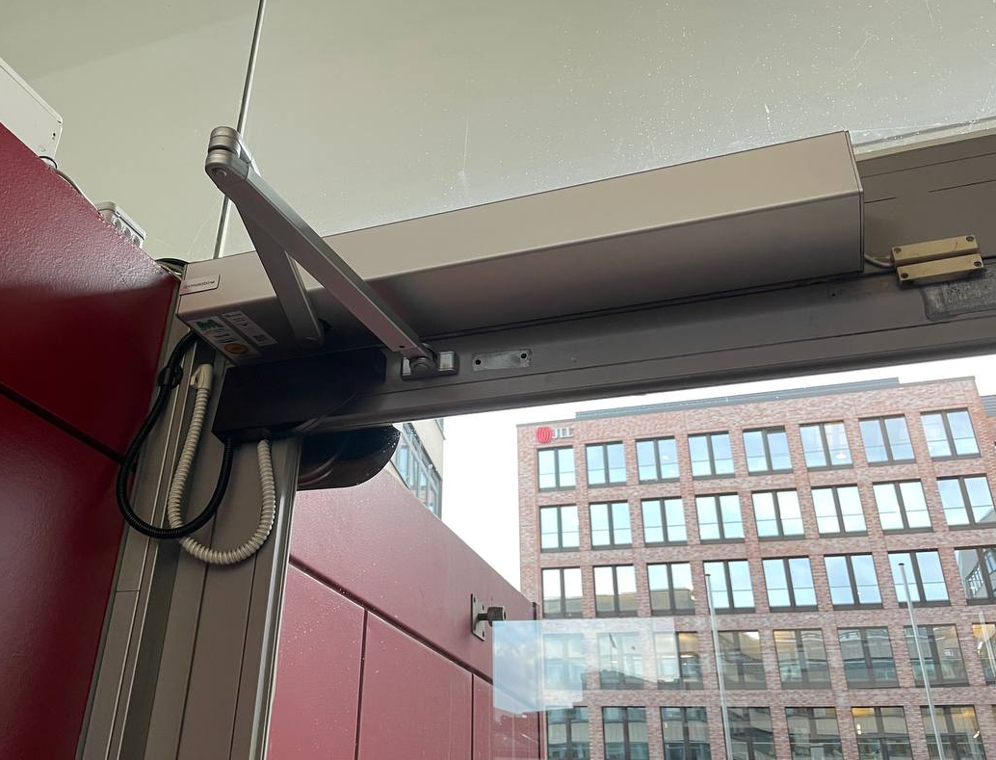 | 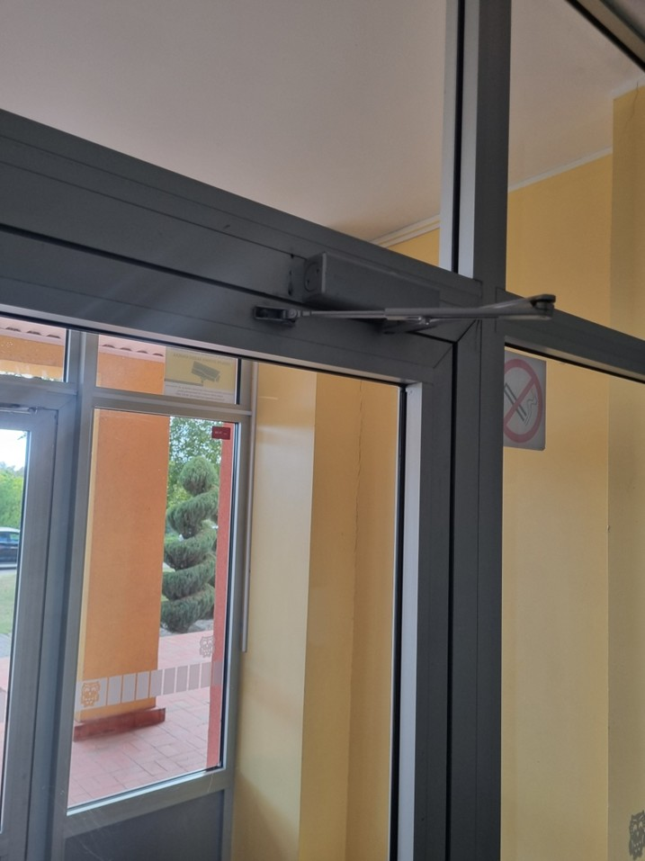
Electric door closer ©Johanna Fink | Door closer © Paistrys Juozas Zikaras Gymnasium

Pipe insulation
Brief description
Uninsulated pipework and fittings can account for up to 10-20 % of the total heating energy consumption of a building, because the pipes shed heat into unheated rooms or walls, before reaching the designated radiator. A useful measure is the thermal insulation of pipes, pipelines, fittings, fixtures and flanges (also hot water storage tanks and containers) with insulating materials and sealing strips to prevent heat escaping. It can be an easy and low-cost way to save energy and reduce costs.
The most important place to insulate is the basement installation, because unheated cellars cause high energy losses right at the starting point of the heat system.
A good place to start is the insulation of easily accessible pipes by wrapping foam tubes around the blank pipes and fittings. This measure can be done in DIY. Other heating appliances might be harder to reach and require a specialist company or maintenance personnel.
#insulation #insulationofpipes #fittings #flanges #pipes #hotwater #watertank #hotwatersupply #watersupply

Thematic allocation |  | Building categories
☒ Insulation | ☐ Electricity production | ☐ Administrative | ☐ Educational or social institution
☒ Energy/ heating system | ☐ Lighting | ☐ Commercial | ☐ Residential housing
☒ Warm water supply | ☐ | ☐ Industrial construction | ☒ All building types

Implementation time | Saving potential
☒ Quick to implement (within a few days) | ☒ Energy | ☒ Costs
☒ Short term (within 12 weeks) | ☒ CO₂
☒ Medium term (within 6 months) | ☒ Other positive Effect:
☐ Long term (longer than 12 months) | Improved heat distribution

Orientation | Priority level | Qualification level | Special safety
☐ Behaviour | ☐ Low | ☒ DIY / own work | ☒ Not necessary
☒ Technical | ☐ Medium | ☒ Specialist company | ☐ Advisable
☒ Construction | ☒ High | ☐ Expert | ☐ Mandatory
Implementation requirements
Investment costs | Return of investment
Preparation and installation of thermal insulation  - foam insulation (e.g. polyethylene): 5-7 €/m  - rubber insulation: 1-5 €/m  - mineral wool insulation: 4-9 €/m | Because of the low investments and the high energy saving potential, the return of the investment is under one year.
Possible subsidies and programs | Availability of the material or technology
Example for Germany  BAFA: Heating optimization | Available in large quantities in many places, for example in hardware stores and online.  Available in many variations with advantages and disadvantages in terms of ecology, price and workability available.
Special requirements, safety precautions, challenges or conditions
Possible resistance from tenants because of the larger space requirements in basements.
High product carbon footprint of the insulation materials made of fossil fuels. Insulation made from sustainable materials (e.g. bio polyethylene, natural rubber, etc.) also available.

Responsibilities / Actors
Mandatory actors and required competencies
Heating company for complex systems in large buildings
Voluntary / helpful actors and competencies
---
Possible implementation partners
---

Implementation process
First steps to initiate the measure:  preparatory actions | Installation instructions and guidelines, How to’s, open source initiatives
- Verification of funding eligibility (in some countries important before contracts are signed).  - Inventory of non-insulated pipes and fittings and subsequent calculation of material requirements.  - Purchase of materials and compilation of the tools and personnel required for implementation.  - If necessary, uncover pipes and create workspace. | Example for Germany  https://redaktion.hessen-agentur.de/publication/2022/3850_DIY-Anleitung-Leitungsdaemmung_final.pdf  https://www.co2online.de/modernisieren-und-bauen/sanierung-modernisierung/heizungsrohre-isolieren-anleitung/
Realization of the main part
- Cutting and fitting the insulation shells with carpet cutters or similar. | 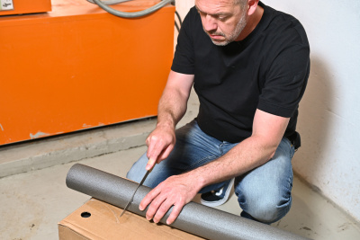  © LEA Hessen, Photo: Rundel
- Insulating straight pipes. | 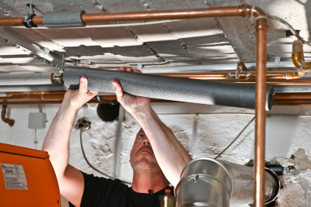  © LEA Hessen, Photo: Rundel
- Insulate curves. | 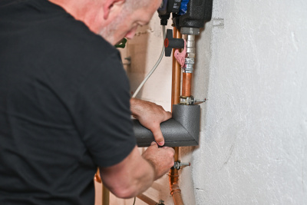  © LEA Hessen, Photo: Rundel
- Insulate T-pieces. | 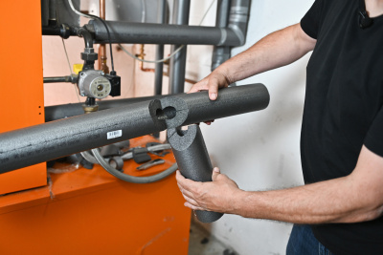  © LEA Hessen, Photo: Rundel
- Insulating valves and fittings, so that they are still useful afterwards. | 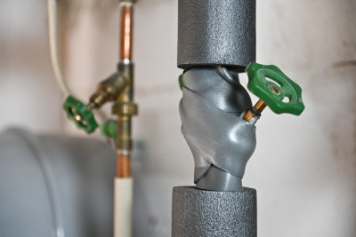  © LEA Hessen, Photo: Rundel
After installation of the measure: maintenance/operation routine | Further comments/ links
- Monitoring and evaluating energy savings.

Photos if available
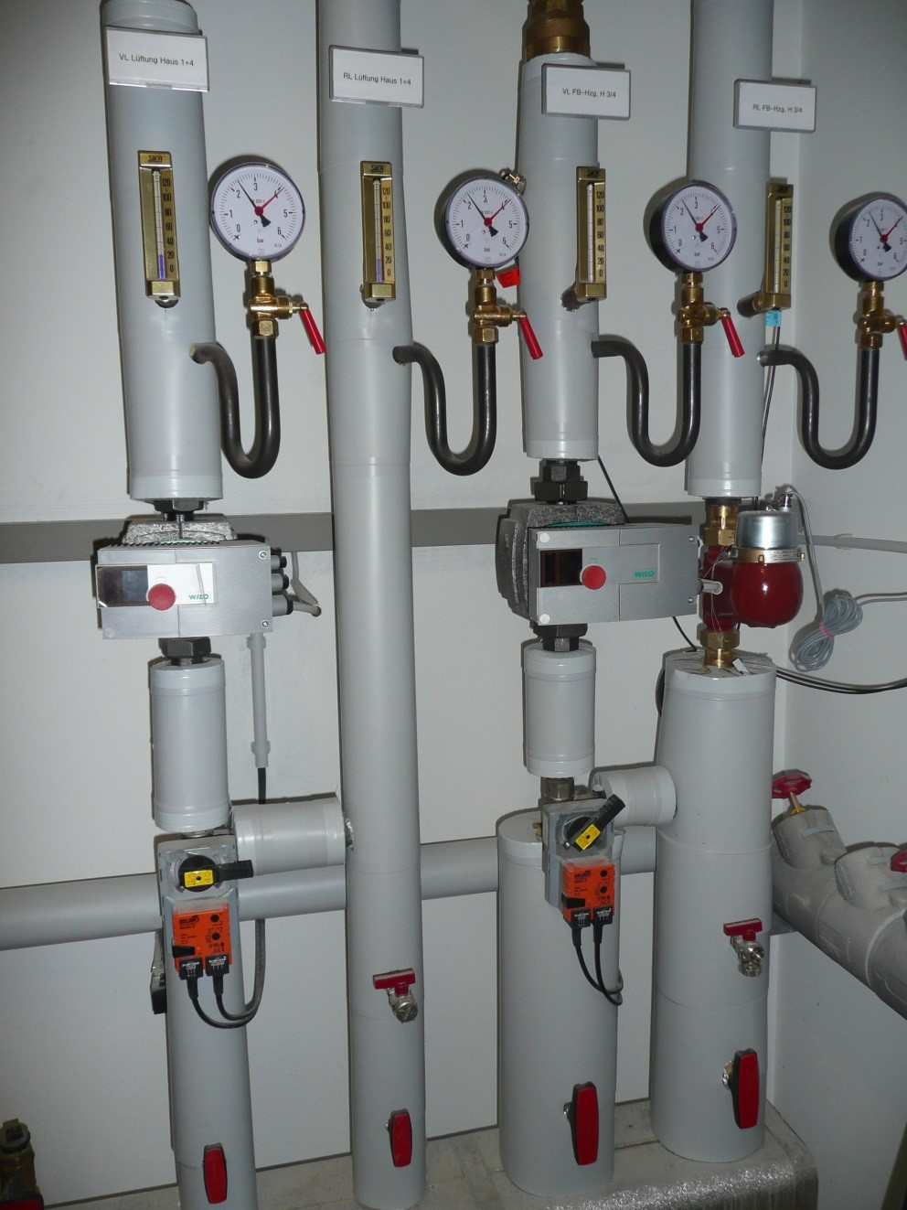 | 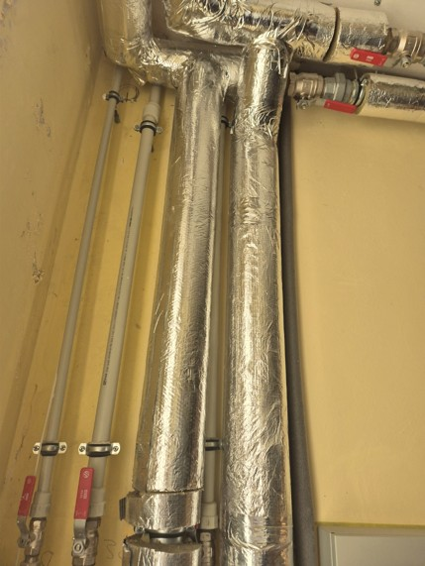
Isolated pipes © ZEBAU GmbH | Isolated pipes © Krekenava Mykolas Antanaitis Gymnasium

Heating, Electricity and Water
- Hydronic balancing
- Heat load management/Smart temperature control
- Smart thermostats
- Temperature control by app
- Visualization of energy consumption/ Energy monitoring
- Lighting adaptation
- Efficient lighting / LED lighting
- Lighting control
- Socket timer/ digital socket plug
- Aerator for water faucet
- Sensor water faucet

Hydronic balancing
Brief description
In old heating systems and after changes to the systems, rooms are often supplied with a different hot water flow rate, which is why radiators that are further away from the heating system often become less warm. This leads to increased fuel consumption.
To heat every room in a building evenly and efficiently, the water flow in each radiator and heating circuit must be regulated. This is done by means of hydronic balancing. This requires a room-by-room heat load calculation and the specification of preset values ​​for the heating valves.
This not only achieves better heat distribution, but also saves energy, as the flow temperature can be lowered by improving the distribution of hot water. In this way, energy consumptions and costs can be reduced up to 15 % and CO₂ emissions from fossil-fuel heating systems are lowered. At the same time, thermostats can be replaced and more efficient pumps installed if necessary. In some countries, hydraulic balancing is a mandatory condition for adapting heating systems and receiving subsidies.
#hydronic balancing #hydraulic balancing #equalisation #alignment #adjustment #heating #radiator #thermostativ valve #valve

Thematic allocation |  | Building categories
☐ Insulation | ☐ Electricity production | ☐ Administrative | ☐ Educational or social institution
☒ Energy/ heating system | ☐ Lighting | ☐ Commercial | ☐ Residential housing
☐ Warm water supply | ☐ | ☐ Industrial construction | ☒ All building types

Implementation time | Saving potential
☒ Quick to implement (within a few days) | ☒ Energy | ☒ Costs
☒ Short term (within 12 weeks) | ☒ CO₂ | Usually 5-7 %, up to 15 %
☐ Medium term (within 6 months) | ☒ Reduced load on the heating system
☐ Long term (longer than 12 months) | Longer service life and lower repair costs

Orientation | Priority level | Qualification level | Special safety
☐ Behaviour | ☐ Low | ☐ DIY / own work | ☐ Not necessary
☒ Technical | ☐ Medium | ☒ Specialist company | ☒ Advisable
☐ Construction | ☒ High | ☐ Expert | ☐ Mandatory

Implementation requirements
Investment costs | Return of investment
From 1000 € (depends on building size)  Retrofitting to preset thermostatic valves cost  30 € / radiator. Replacing the heat circulation pump is around 300-400 €. | return of investment within two years  (with 15 % energy and cost savings)  between three and a half and six years with lower savings or expensive installation
Possible subsidies and programs | Availability of the material or technology
Example for Germany  The Federal Subsidy for Efficient Buildings (BEG) promotes investments in energy efficiency for all building types. The costs for hydronic balancing are eligible for funding as part of the heating optimization of individual measures (for non-residential buildings with a heated area of up to 1,000 m²). In addition, hydronic balancing is even a minimum technical requirement for the eligibility of some other energy efficiency measures and is therefore also eligible for funding in these cases. | The measure is relatively uncomplicated, and materials are easy to procure, which makes it easy to convince decision-makers.
Special requirements, safety precautions, challenges or conditions
Accessibility to all heating equipment and radiators and radiators need pre-settable valves.
Lack of data can lead to a more time-consuming process.

Responsibilities / Actors
Mandatory actors and required competencies
An energy consultant or architect who calculates the heating loads and a heating systems installer who installs the heating valves in the heating circuit.
Voluntary / helpful actors and competencies
---
Possible implementation partners
---

Implementation process
First steps to initiate the measure:  preparatory actions | Installation instructions and guidelines, How to’s, open source initiatives
- Before hydronic balancing can be carried out the heating load must be calculated. The heat requirement is determined, the temperature difference to the minimum outside temperature and the operating conditions of the heating system and the system is checked for functionality.  - The hydraulic data is then determined. This includes the flow rate, flow and return temperature, pressure losses and the pump pressure. | Example for Germany  https://shk-info.de/hydraulischen-abgleich-im-bestandsgebaeude  https://www.energiewechsel.de/KAENEF/Redaktion/DE/Downloads/Dialog-Energiewechsel/energiewechsel_faktenblatt-hydraulischer-abgleich.pdf?__blob=publicationFile&v=6raulischer Abgleich
Realization of the main part | Accompanying communication
- Once this data has been collected, hydronic balancing can be carried out.  - Each radiator is set to a specific flow rate. At a certain flow temperature at the operating point of the heating system, each room should be supplied with the amount of heat required to reach the desired room temperature. The return flow of each radiator must have almost the same temperature.  - Before the work is completed, all settings and radiators should be checked so that adjustments can be made if necessary. | After installation, inform building users how the thermostatic valves should remain set to achieve optimum efficiency.
After installation of the measure: maintenance/operation routine | Further comments/ links
- Once the measure has been optimally implemented, no maintenance is required.  - If structural changes are made later, like window replacement or installation of building insulation, the heat calculation could be updated, and the valves could be readjusted. | Example for Germany  Since 2014, hydraulic balancing is mandatory for new or replaced hot water heating systems in Germany

Photos if available
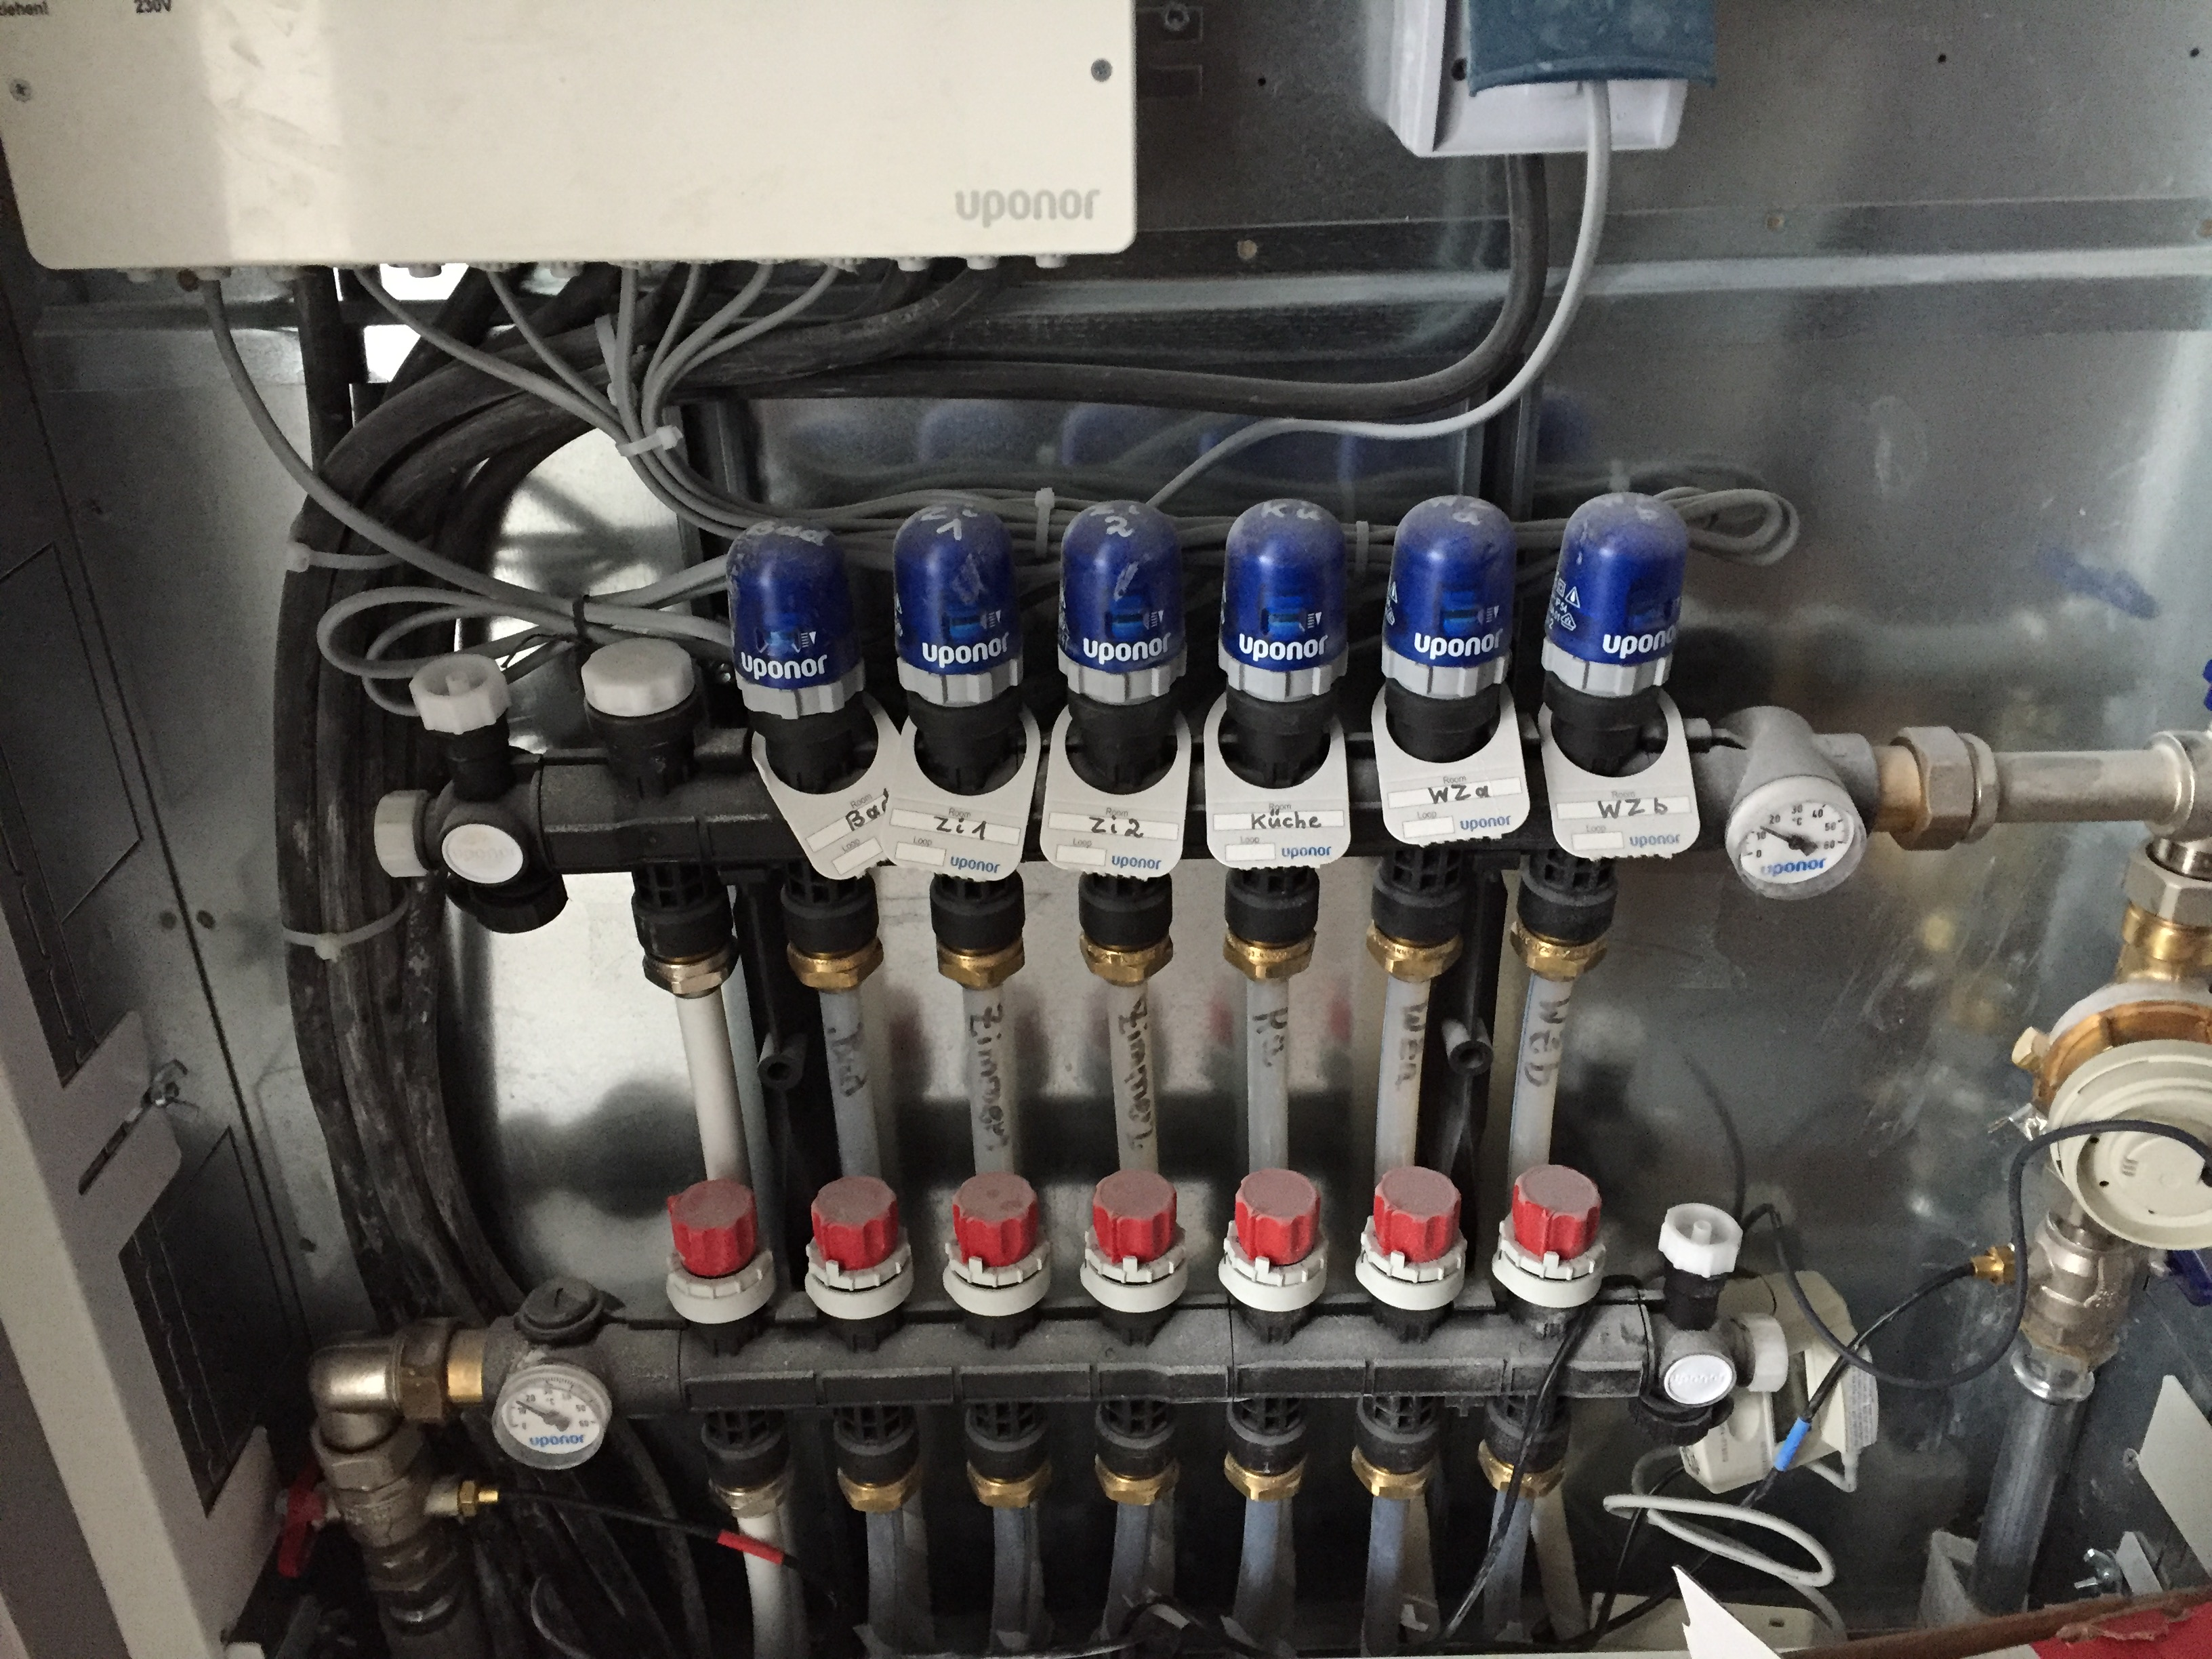
Pre adjustment of floor heating system © ZEBAU

Heat load management/Smart temperature control
Brief description
Heat load management includes the calculation of heat load, as well as the temperature control itself. Determining the heat load for a building at different times shows potential for energy reductions, for example overnight or in unused rooms. For periods with low heat load, smart temperature control is used to lower the room temperature. This can be done through automation of the heating system or timed shut-off valves at radiators and is especially efficient in older, less insulated buildings, where heat losses through the night/ unoccupied period would far outweigh the additional energy to reheat in the morning. Energy savings through night reduction lie between 5 % and 15 %.
Additionally, heating systems can be connected to an outside temperature sensor, so that the heating system performs adequately based on the temperature difference between indoor and outdoor temperature. This reduces the risk of overheating on warmer days and reduces energy use by 30 %.
The effort required to operate this system includes not only the actual installation but also the introduction, ongoing training, and possibly continuous support.
#heatingload #heatloadcalculation #decisionaid #smarttemperaturecontrol #smarthome #smartbuildings #nightreduciton #summerreduction #roomtemperature

Thematic allocation |  | Building categories
☐ Insulation | ☐ Electricity production | ☐ Administrative | ☐ Educational or social institution
☒ Energy/ heating system | ☐ Lighting | ☐ Commercial | ☐ Residential housing
☐ Warm water supply | ☐ | ☐ Industrial construction | ☒ All building types

Implementation time | Saving potential
☒ Quick to implement (within a few days) | ☒ Energy | ☒ Costs
☒ Short term (within 12 weeks) | ☒ CO₂ | Up to 30 % reduction
☐ Medium term (within 6 months) | ☒ Other positive Effect:
☐ Long term (longer than 12 months) | Precise temperature comfort, self-efficacy

Orientation | Priority level | Qualification level | Special safety
☒ Behaviour | ☒ Low | ☒ DIY / own work | ☒ Not necessary
☒ Technical | ☐ Medium | ☒ Specialist company | ☐ Advisable
☐ Construction | ☐ High | ☐ Expert | ☐ Mandatory

Implementation requirements
Investment costs | Return of investment
Outdoor sensor and thermostat 50-100 €  Complete automation systems with smart controller/ app and radiator thermostats up to 500 € | Amortization period for smart temperature control 1-3 years.  Life Span 10 years.
Possible subsidies and programs | Availability of the material or technology
Example for Germany  Currently no German funding programs for this measure available. | The measure is uncomplicated, and materials / tools are easy to procure.
Special requirements, safety precautions, challenges or conditions
Useful criteria when selecting a technology provider is the available for visualizations and evaluations without the need for additional hardware purchases.

Responsibilities / Actors
Mandatory actors and required competencies
Heating company who installs the heating valves
Voluntary / helpful actors and competencies
Supplier of appropriate system technology, energy consultant
Possible implementation partners
---

Implementation process
First steps to initiate the measure:  preparatory actions | Installation instructions and guidelines, How to’s, open source initiatives
- Analysis of the heat load and the required temperature, building structure and heating system compatibility.  - Evaluation of the possible nighttime reduction or other reduction periods through experts is advisable. | Example for Germany  https://testing.verbraucherzentrale-energieberatung.de/heizen/heizung-optimieren/nachtabsenkung/
Realization of the main part | Accompanying communication
- Procuring equipment or ordering service from a heating company.  - Installation of valves, sensors, automation equipment and timers.  - Setting timers, programming scenarios for automation. | Information for tenants, employees
After installation of the measure: maintenance/operation routine | Further comments/ links
- Training for proper use.
- Monitoring of operation.

Smart thermostats
Brief description
From 30 % in manufacturing industry up to 50 % of energy demand for offices occur from heating systems. This offers a great energy saving potential by reducing the room temperature where possible. This can be done with smart thermostats.
A smart thermostat automatically regulates the temperature of radiators to lower costs for heating in winter. When rooms or buildings are unoccupied, the temperature is reduced for example after operation hours or at night. It is important to keep the temperature above 16 °C on insulated walls, to reduce the possibility of mould infestation. The amount of reduction can vary for different building structure and building type.
Smart Thermostats can be programmed to automatically operate, which is especially useful for buildings with fixed operation/occupancy hours like offices or schools.
#heatingcontrol #energysaving #thermostat #smartthermostats

Thematic allocation |  | Building categories
☐ Insulation | ☐ Electricity production | ☐ Administrative | ☐ Educational or social institution
☒ Energy/ heating system | ☐ Lighting | ☐ Commercial | ☐ Residential housing
☐ Warm water supply | ☐ | ☐ Industrial construction | ☒ All building types

Implementation time | Saving potential
☒ Quick to implement (within a few days) | ☒ Energy | ☒ Costs
☐ Short term (within 12 weeks) | ☒ CO₂ | Saves 10- 20 % of heating energy and costs
☐ Medium term (within 6 months) | ☐ Other positive Effect
☐ Long term (longer than 12 months)

Orientation | Priority level | Qualification level | Special safety
☒ Behaviour | ☒ Low | ☒ DIY / own work | ☒ Not necessary
☒ Technical | ☐ Medium | ☒ Specialist company | ☐ Advisable
☐ Construction | ☐ High | ☐ Expert | ☐ Mandatory

Implementation requirements
Investment costs | Return of investment
50-100 € for automatic programmable thermostats. | Depending on energy prices and heating behaviour, return of investment between a few months and up to 3 years.
Possible subsidies and programs | Availability of the material or technology
Example for Germany  Currently no German funding programs for this measure available. | Thermostats can usually be purchased at hardware or specialty stores, a wide selection of devices, available immediately.
Special requirements, safety precautions, challenges or conditions
---

Responsibilities / Actors
Mandatory actors and required competencies
---
Voluntary / helpful actors and competencies
Specialist company for installation, especially for large commercial properties or offices
Possible implementation partners
Janitor, maintenance personnel

Implementation process
First steps to initiate the measure:  preparatory actions | Installation instructions and guidelines, How to’s, open source initiatives
- Calculation of indoor temperatures and heat load.  - Decision on type of thermostat (remotely controlled or programmable).  - Procuring specialist company if needed. | Example for Germany  https://www.effizienznetzwerke.org/app/ uploads/2023/12/Netzwerkinitiative_ Factsheet_Bedarfsgerechte-Raumwaerme-durch-automatisierte-Thermostate.pdf  https://www.youtube.com/watch?v=N4c1AF7oBa8 es
Realization of the main part | Accompanying communication
- Installation of thermostats to the radiator according to the included manufacturer's instructions or installation by specialist company. | Information about operation for office workers, tenants
After installation of the measure: maintenance/operation routine | Further comments/ links
- If the thermostat is programmable, once programmed, no action is required.  - Checking devices regularly for low battery. | Reducing indoor temperature to less than 16 degrees in insulated rooms can incite mould infestations.

Photos if available
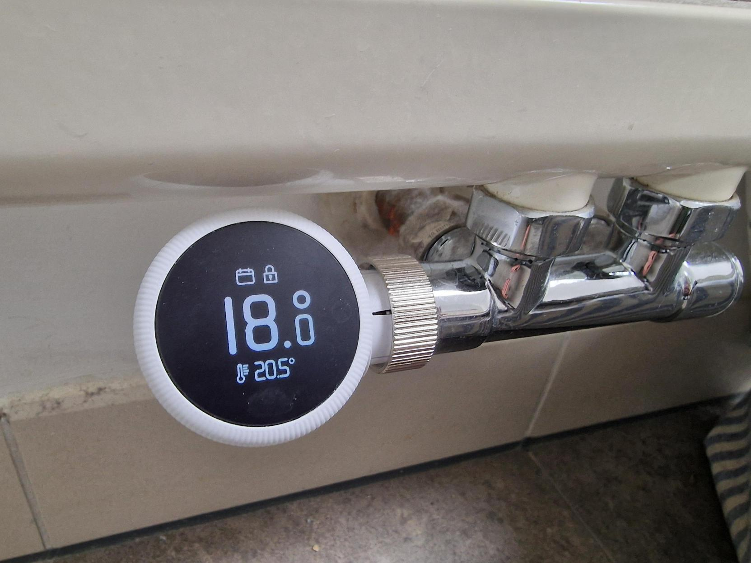
SmartHome Thermostat © ZEBAU GmbH

Temperature control by app
Brief description
The energy demand for heating rooms and buildings is very extensive and offers great saving potential, especially for buildings or rooms that are unoccupied at night but continue to be heated, or that are infrequently occupied, like hotel rooms or guesthouses.
The greatest energy consumption for heating is caused by electric heaters, which can be equipped with controllable devices that switch the radiators to a lower temperature remotely via an appropriate app or switch them off when the rooms are not occupied.
Instead of running these devices or a conventional heater permanently or turning them up daily after a night-time reduction, they can be turned up when needed via an app before the person using them is on site.
#electricityconsumptioncontrolling, #smartsolutions #smarthome

Thematic allocation |  | Building categories
☐ Insulation | ☐ Electricity production | ☐ Administrative | ☐ Educational or social institution
☒ Energy/ heating system | ☐ Lighting | ☒ Commercial | ☒ Residential housing
☐ Warm water supply | ☐ | ☐ Industrial construction | ☒ Accommodation

Implementation time | Saving potential
☒ Quick to implement (within a few days) | ☒ Energy | ☒ Costs
☐ Short term (within 12 weeks) | ☒ CO₂ | 10-15 % energy saving
☐ Medium term (within 6 months) | ☐ Other positive Effect
☐ Long term (longer than 12 months)

Orientation | Priority level | Qualification level | Special safety
☐ Behaviour | ☒ Low | ☒ DIY / own work | ☒ Not necessary
☒ Technical | ☒ Medium | ☒ Specialist company | ☐ Advisable
☐ Construction | ☐ High | ☐ Expert | ☐ Mandatory

Implementation requirements
Investment costs | Return of investment
125 € per unit with installation. | Approximate payback within 10 months.
Possible subsidies and programs | Availability of the material or technology
Example for Germany  Currently no German funding programs for this measure available. | Many different solutions available on the market.
Special requirements, safety precautions, challenges or conditions
---

Responsibilities / Actors
Mandatory actors and required competencies
---
Voluntary / helpful actors and competencies
Measure can be done as DIY or with a specialist company.
Possible implementation partners
---

Implementation process
First steps to initiate the measure:  preparatory actions | Installation instructions and guidelines, How to’s, open source initiatives
- Metering of consumption to assess potential savings.
- Deciding on a solution system.
Realization of the main part | Accompanying communication
- Procuring equipment or ordering service from a specialist company.  - Installation of devices on radiators.  - Activation of app.  - If possible, installation of a separate metering device. | Training for employees if applicable to use the app appropriately.
After installation of the measure: maintenance/operation routine | Further comments/ links
- Metering of consumption to control energy saving. | Low priority for residential homes but higher priority for commercial properties with vacancies like guest houses or accommodation.

Photos if available
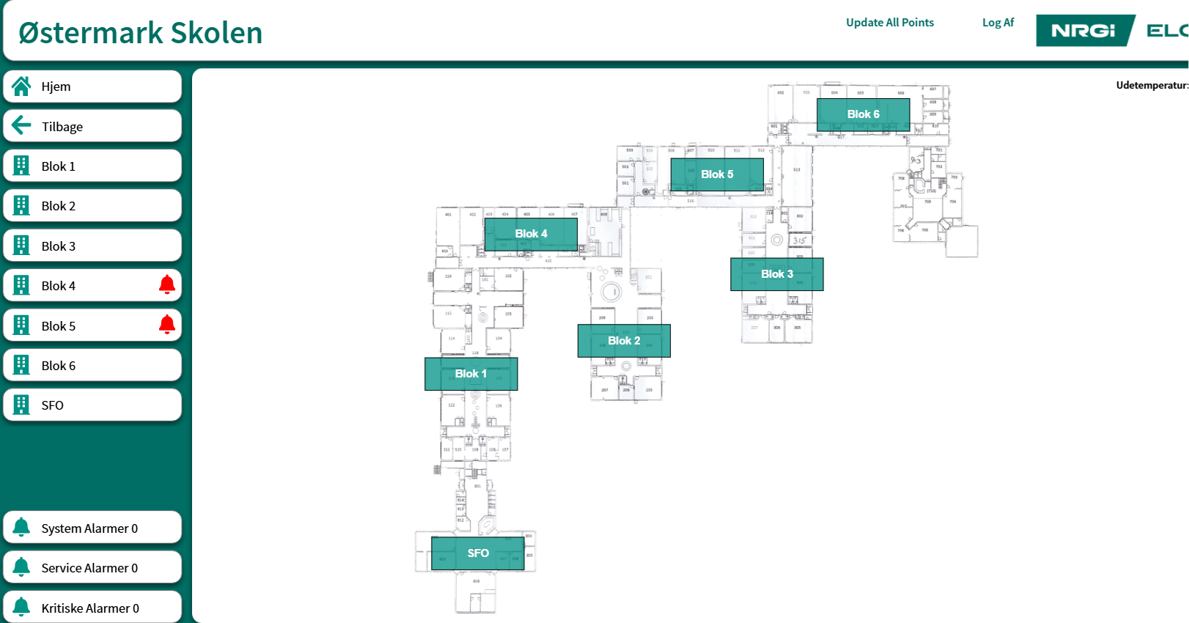
Energymanagementsystem © Vesthimmerlands Kommune

Visualization of energy consumption/ Energy monitoring
Brief description
To address energy consumption and change the behavior to reduce energy demand effectively, it is important to have a detailed overview over the consumption. This can be done through power meters that record energy use and technically supported monitoring and evaluation of consumption data, which can be shown on screen. The data ca be accessible to the employees / users of a building and directly influence energy consumption through optimized user behavior. This measure is especially useful for large buildings with very high energy consumption (office, commercial, industrial).
The effort and costs of implementing energy consumption visualization vary considerably, depending on the existing infrastructure and energy management systems in use. With existing metering infrastructure and monitoring systems, visualization is often quick and cost-effective to implement and is offered by providers as an add-on.
#energyvisualization #buildingmonitoring #energy #consumption #energyanalytics #buildingperformance #energymonitoring #datadrivenbuildings #sustainabletech #smartgrid #energyawareness #smartenergy

Thematic allocation |  | Building categories
☐ Insulation | ☐ Electricity production | ☐ Administrative | ☐ Educational or social institution
☐ Energy/ heating system | ☐ Lighting | ☐ Commercial | ☐ Residential housing
☐ Warm water supply | ☒ Monitoring | ☐ Industrial construction | ☒ All building types

Implementation time | Saving potential
☒ Quick to implement (within a few days) | ☒ Energy | ☒ Costs
☒ Short term (within 12 weeks) | ☒ CO₂
☐ Medium term (within 6 months) | ☒ Other positive Effect:
☐ Long term (longer than 12 months) | Creates Awareness

Orientation | Priority level | Qualification level | Special safety
☒ Behaviour | ☐ Low | ☐ DIY / own work | ☒ Not necessary
☐ Technical | ☒ Medium | ☒ Specialist company | ☐ Advisable
☐ Construction | ☐ High | ☐ Expert | ☐ Mandatory

Implementation requirements
Investment costs | Return of investment
Investment costs range from less than 500 € to approximately 2.000 €, depending on the system and configuration.  Option of small power meters for single sockets from 10 € but no visualization or evaluation. | Depending on behaviour change or implementation of energy efficiency measures, cost savings can lead to return of investment.
Possible subsidies and programs | Availability of the material or technology
Example for Germany  Currently no German funding programs for this measure available. | Readily available
Special requirements, safety precautions, challenges or conditions
---

Responsibilities / Actors
Mandatory actors and required competencies
---
Voluntary / helpful actors and competencies
Specialist company for installation in large buildings advisable
Possible implementation partners
Technical personnel, maintenance personnel

Implementation process
First steps to initiate the measure:  preparatory actions | Installation instructions and guidelines, How to’s, open source initiatives
- Determining the extent and type of data that should be collected.
- Deciding on a spot for showing the data output, easily accessible, high visibility.
Realization of the main part | Accompanying communication
- Procuring system or ordering a specialist company.  - Installing power meters for the entire building or determined appliances/ power points to collect information on used and produced (if applicable) power.  - Connecting to screen or system to visualize output and evaluation of energy consumption. | Information for employees or tenants on how to read/ interpret the energy consumption
After installation of the measure: maintenance/operation routine | Further comments/ links
- Regular control to monitor changes and ensure energy savings.

Photos if available
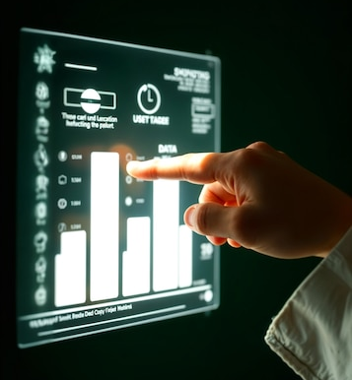
Energy consumption display © designed by Magnific (www.magnific.com)

Lighting adaptation
Brief description
The energy demand for lighting can be up to 50% of the energy demand in offices and administration buildings. Apart from changing the rate of efficiency in the lighting fixtures, it can also be useful to reduce the lux, which means the illuminance of the room or workplace. By adapting a standard lux availability requirement, it is possible to reduce lighting, where it is not needed and therefore reduce energy. The standard requirements would be:
- 500 lx handwriting, keyboard operation, conference rooms, computer workstations
- 300 lx reception, filing documents, copying
- 200 lx archives
- 100 – 200 lx corridor
To ensure minimum lighting, the lux should be measured in winter or with no daylight, however the use of daylight is recommended where possible. Lighting can be used to complement low daylight.
Adjusting the lighting situation is usually combined with replacing the light sources, so the savings effects cannot be clearly attributed to the individual measures.
##easyenergy #wesaveenergy #efficientlighting #led #lighting

Thematic allocation |  | Building categories
☐ Insulation | ☐ Electricity production | ☒ Administrative | ☐ Educational or social institution
☐ Energy/ heating system | ☒ Lighting | ☒ Commercial | ☐ Residential housing
☐ Warm water supply | ☐ | ☐ Industrial construction | ☐

Implementation time | Saving potential
☐ Quick to implement (within a few days) | ☒ Energy | ☒ Costs
☒ Short term (within 12 weeks) | ☐ CO₂
☐ Medium term (within 6 months) | ☒ Other positive Effect:
☐ Long term (longer than 12 months) | Health benefits through adequate lighting

Orientation | Priority level | Qualification level | Special safety
☐ Behaviour | ☒ Low | ☒ DIY / own work | ☒ Not necessary
☒ Technical | ☐ Medium | ☐ Specialist company | ☐ Advisable
☐ Construction | ☐ High | ☐ Expert | ☐ Mandatory

Implementation requirements
Investment costs | Return of investment
2- 20 € per LED light bulb | Minimal investment, since not all lightbulbs have to be exchanged. ROI within a year.
Possible subsidies and programs | Availability of the material or technology
Example for Germany  Funding is possible for exchanging old lamps to new efficient LED lamps.  In addition German funding program “Renovation of interior and hall lighting” (“Sanierung von Innen- und Hallenbeleuchtung“ im Rahmen der sog. Kommunalrichtlinie der Nationalen Klimaschutzinitiative) | New light bulbs are easily accessible.
Special requirements, safety precautions, challenges or conditions
---

Responsibilities / Actors
Mandatory actors and required competencies
---
Voluntary / helpful actors and competencies
Electric company for installation, especially in large buildings
Possible implementation partners
Janitor, maintenance personnel

Implementation process
First steps to initiate the measure:  preparatory actions | Installation instructions and guidelines, How to’s, open source initiatives
- Measuring light intensity indoors with special measurement instruments or with smart phone apps like “Lux-O-Meter” which uses camera sensors to register light.
- Determining the lighting requirements in different rooms or workstations in cooperation with employees.
- Purchase lighting fixtures with the desired amount of lux.
Realization of the main part | Accompanying communication
- Removal of unnecessary or high lux light sources.
- Installation of adequate lighting.
After installation of the measure: maintenance/operation routine | Further comments/ links
- Verification of savings.  - Monitoring of changes in lighting requirements. | Older light sources should be replaced with higher priority than new light sources.  Light bulbs dismantled to reduce the number of lux will serve as emergency/backup.

Photos if available
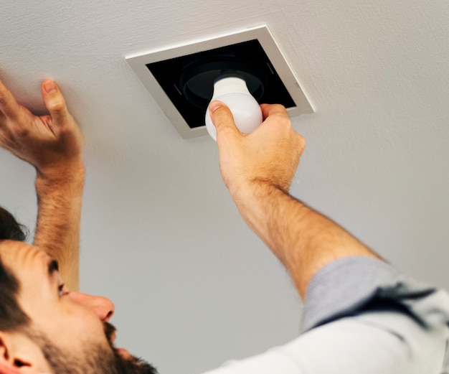
Llight bulb Installation © designed by Magnific (www.magnific.com)

Efficient lighting / LED lighting
Brief description
The energy use for lighting varies heavily depending on the sector, it is up to 20 % of electricity production in industry, up to 50 % in the service sector, and up to 70 % in retail. Residential buildings usually have a significantly lower lighting energy demand.
An easy way to reduce the energy demand is to replace inefficient lighting fixtures with new efficient ones like LED light bulbs. This can also provide better light quality and comfort at the workplace. LED lights don’t shed heat energy like old lightbulbs do, which is a large part of the reduced energy demand. Furthermore, it reduces the excess internal heat during summer which can come from appliances and disrupt a comfortable interior climate.
This measure can be coupled with lighting adaptation, which reduces the energy by reducing illuminance where not necessary.
#electricitysaving #energysaving #lighting #led #ledlights #efficientlighting

Thematic allocation |  | Building categories
☐ Insulation | ☒ Electricity production | ☐ Administrative | ☐ Educational or social institution
☐ Energy/ heating system | ☐ Lighting | ☐ Commercial | ☐ Residential housing
☐ Warm water supply | ☐ | ☐ Industrial construction | ☒ All building types

Implementation time | Saving potential
☒ Quick to implement (within a few days) | ☒ Energy | ☒ Costs
☒ Short term (within 12 weeks for large building) | ☒ CO₂
☐ Medium term (within 6 months) | ☒ Other positive Effect:  Improved lighting comfort. Less maintenance because of longer life span. Less heat from light bulbs.
☐ Long term (longer than 12 months)

Orientation | Priority level | Qualification level | Special safety
☐ Behaviour | ☐ Low | ☒ DIY / own work | ☒ Not necessary
☒ Technical | ☒ Medium | ☒ Specialist company | ☐ Advisable
☐ Construction | ☒ High | ☐ Expert | ☐ Mandatory

Implementation requirements
Investment costs | Return of investment
Between 2€ and 20€ per LED light bulb | 6 months to 5 years (depending on scale of renovation and electricity price).
Possible subsidies and programs | Availability of the material or technology
Example for Germany  In Germany, the installation of energy efficient interior lighting systems can be subsidised by BAFA, as long it has a minimum cost of 300 Euros and is implemented in non-residential buildings like offices or public buildings.  In addition German funding program “Renovation of interior and hall lighting” (“Sanierung von Innen- und Hallenbeleuchtung“ im Rahmen der sog. Kommunalrichtlinie der Nationalen Klimaschutzinitiative) | New light bulbs are easily accessible.
Special requirements, safety precautions, challenges or conditions
---

Responsibilities / Actors
Mandatory actors and required competencies
---
Voluntary / helpful actors and competencies
Lighting specialist, electric company for installation (especially for large buildings)
Possible implementation partners
Janitor, maintenance personnel

Implementation process
First steps to initiate the measure:  preparatory actions | Installation instructions and guidelines, How to’s, open source initiatives
- Mapping existing light fixtures and lighting standards.
- Procuring lighting specialist if necessary.
- Calculating the new lighting fixtures to meet standards and needs.
Realization of the main part | Accompanying communication
- Visit of a lighting specialist if necessary.  - Identification of places that need additional illumination.  - Purchase and installation of new LED lighting in DIY or with electric company. | Possible inclusion of employees in the decision of light fixtures, lighting intensity and lighting needs.
After installation of the measure: maintenance/operation routine | Further comments/ links
- Ongoing tracking of changes in lighting technology. | High priority for very old lighting, lower priority for newer installations.  Gradual exchange process possible.

Photos if available
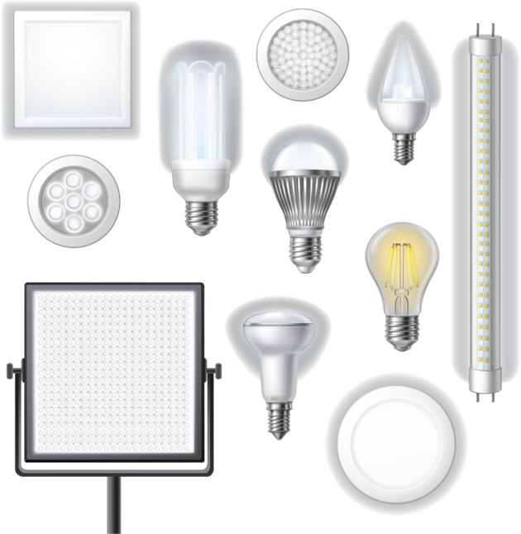
Various lightbulbs © designed by Magnific (www.magnific.com)

Lighting control
Brief description
Lighting control can be used to reduce the energy input for lighting both inside the buildings and in the surrounding outdoor area. This can be done by automatically turning off appliances through:
Timer (office, schools, commercial buildings) or daylight sensor, that automatically switch off lighting after a programmed time. This is most effective in buildings with fixed operating hours. Outdoor lighting can turn on through daylight sensor at dusk and automatically switch off at a designated time.
Occupancy sensors through passive infrared (PIR) sensors, which detect the presence or absence of people and turn lights on and off accordingly. Triggering occurs when a change in infrared levels is detected (when a warm object moves in or out of view of one of the sensors). They are used most effectively in spaces that are often unoccupied. Passive infrared sensors can reduce lighting energy consumption by up to 50 %-90 %.
Motion sensors are best used for passageways or rooms not generally occupied (toilets). The light appliances turn on when the sensor gets triggered and turn off after a programmed time.
##easyenergy #wesaveenergy #PIRsensor #occupancysensor #energysavingsensor #electricitysavings #smartlighting #automation #lightingautomation #smarthometech #automatization #smartbuilding

Thematic allocation |  | Building categories
☐ Insulation | ☐ Electricity production | ☒ Administrative | ☒ Educational or social institution
☐ Energy/ heating system | ☒ Lighting | ☒ Commercial | ☐ Residential housing
☐ Warm water supply | ☐ | ☒ Industrial construction | ☐ All building types

Implementation time | Saving potential
☒ Quick to implement (within a few days) | ☒ Energy | ☒ Costs
☐ Short term (within 12 weeks) | ☒ CO₂
☐ Medium term (within 6 months) | ☒ Other positive Effect:
☐ Long term (longer than 12 months) | Convenience

Orientation | Priority level | Qualification level | Special safety
☒ Behaviour | ☐ Low | ☒ DIY / own work | ☒ Not necessary
☒ Technical | ☒ Medium | ☐ Specialist company | ☐ Advisable
☐ Construction | ☐ High | ☐ Expert | ☐ Mandatory

Implementation requirements
Investment costs | Return of investment
The price of a programmable timer is 15 -20 €. Passive infrared sensors start at 20€ but can be up to 250 € for systems including lighting fixtures. | Investment is returned within 6 months or less for large spaces like storage halls/archives.  For hallways, toilets and other frequently occupied rooms is between 1 and 2 years.
Possible subsidies and programs | Availability of the material or technology
Example for Germany  German funding program “Renovation of interior and hall lighting” (“Sanierung von Innen- und Hallenbeleuchtung“ im Rahmen der sog. Kommunalrichtlinie der Nationalen Klimaschutzinitiative) | Different timers (dial, digital, smart) and sensors can be easily obtained.
Special requirements, safety precautions, challenges or conditions
PIR sensors are temperature sensitive; they work optimally at ambient air temperatures of 15-20° C.
The room/circuit wattage must be sufficient.
Sensors must be positioned carefully so that they only detect in the intended area. They are best used within a 4-5 metre range, since the detection is less precise with larger distance.

Responsibilities / Actors
Mandatory actors and required competencies
---
Voluntary / helpful actors and competencies
Lighting specialist
Possible implementation partners
---

Implementation process
First steps to initiate the measure:  preparatory actions | Installation instructions and guidelines, How to’s, open source initiatives
- Identifying opportunities for sensor-controlled lighting.  - Selecting the appropriate sensor by taking the room size and the detection range of sensors into consideration.  - Ensuring that installation requirements are compatible with the existing electric setup.  - Planning sensor placement with building personnel/employees. | https://www.energysavingsensors.com/General-Information.htm
Realization of the main part | Accompanying communication
- Installation of the device on the wall or ceiling following instructions and considering installation height, angle, direction, and position. PIR Sensors should not aim to glass windows, HVAC ducts or heat flow sources like radiators.  - Testing functionality of the sensor. | Train maintenance personnel and office occupants to keep sensors operational, rather than disconnecting them as problems occur
After installation of the measure: maintenance/operation routine | Further comments/ links
- Regular maintenance, troubleshooting promptly so that sensors can perform optimally and extend the life span of the light fittings or light bulbs that they're switching.

Photos if available
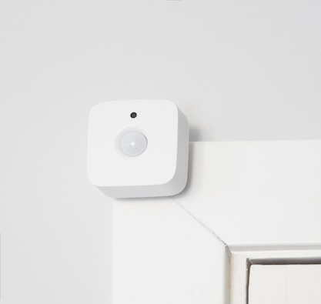
Motion sensor © designed by Magnific (www.magnific.com)

Socket timer/ digital socket plug
Brief description
The share of electricity consumption by office equipment and IT infrastructure in the total energy consumption in offices is usually between 30 % and 50 %. This range varies depending on the type and size of the office and the number and type of equipment used.
To control energy consumption, sockets with timers can be used to automatically switch devices on or off. They are particularly useful for automating everyday tasks like lights, climate appliances or others at specific times. The timer is placed between the socket and the device. The program function allows users to set the desired times when the device should operate. This not only helps save energy, but also increases security, for example by simulating light when no one is at home. Newer models with screens are even able to monitor and show the energy consumption of its connected device.
#digitalsockettimer #smartsocket #sockettimer #smartsocketplug

Thematic allocation |  | Building categories
☐ Insulation | ☐ Electricity production | ☐ Administrative | ☐ Educational or social institution
☒ Energy/ heating system | ☐ Lighting | ☐ Commercial | ☐ Residential housing
☐ Water heating supply | ☐ | ☐ Industrial construction | ☒ All building types

Implementation time | Saving potential
☒ Quick to implement (within a few days) | ☒ Energy | ☒ Costs
☐ Short term (within 12 weeks) | ☒ CO₂
☐ Medium term (within 6 months) | ☒ Other positive Effect:
☐ Long term (longer than 12 months) | Security through simulated lights or sound, monitoring of electricity consumption

Orientation | Priority level | Qualification level | Special safety
☒ Behaviour | ☒ Low | ☒ DIY / own work | ☒ Not necessary
☒ Technical | ☐ Medium | ☐ Specialist company | ☐ Advisable
☐ Construction | ☐ High | ☐ Expert | ☐ Mandatory

Implementation requirements
Investment costs | Return of investment
5-25 € per socket timer | Minimal investment costs with quick return of investment depending on behaviour and electricity prices.
Possible subsidies and programs | Availability of the material or technology
Example for Germany  Currently no German funding programs for this measure available. | Sockets with timers, programmable timers are generally available in a wide range with different functions.
Special requirements, safety precautions, challenges or conditions
---

Responsibilities / Actors
Mandatory actors and required competencies
---
Voluntary / helpful actors and competencies
---
Possible implementation partners
Janitor/ maintenance personnel in large buildings

Implementation process
First steps to initiate the measure:  preparatory actions | Installation instructions and guidelines, How to’s, open source initiatives
- Determining of appliances that could benefit from a socket timer or digital socket plug.
- Procuring a suitable socket timer.
Realization of the main part | Accompanying communication
- Installation of the socket timer.  - Programming of desired times, scenarios for appliances. | Information for employees if applicable
After installation of the measure: maintenance/operation routine | Further comments/ links
- Monitoring electricity consumption through device if possible.
- Verification of energy savings.

Photos if available
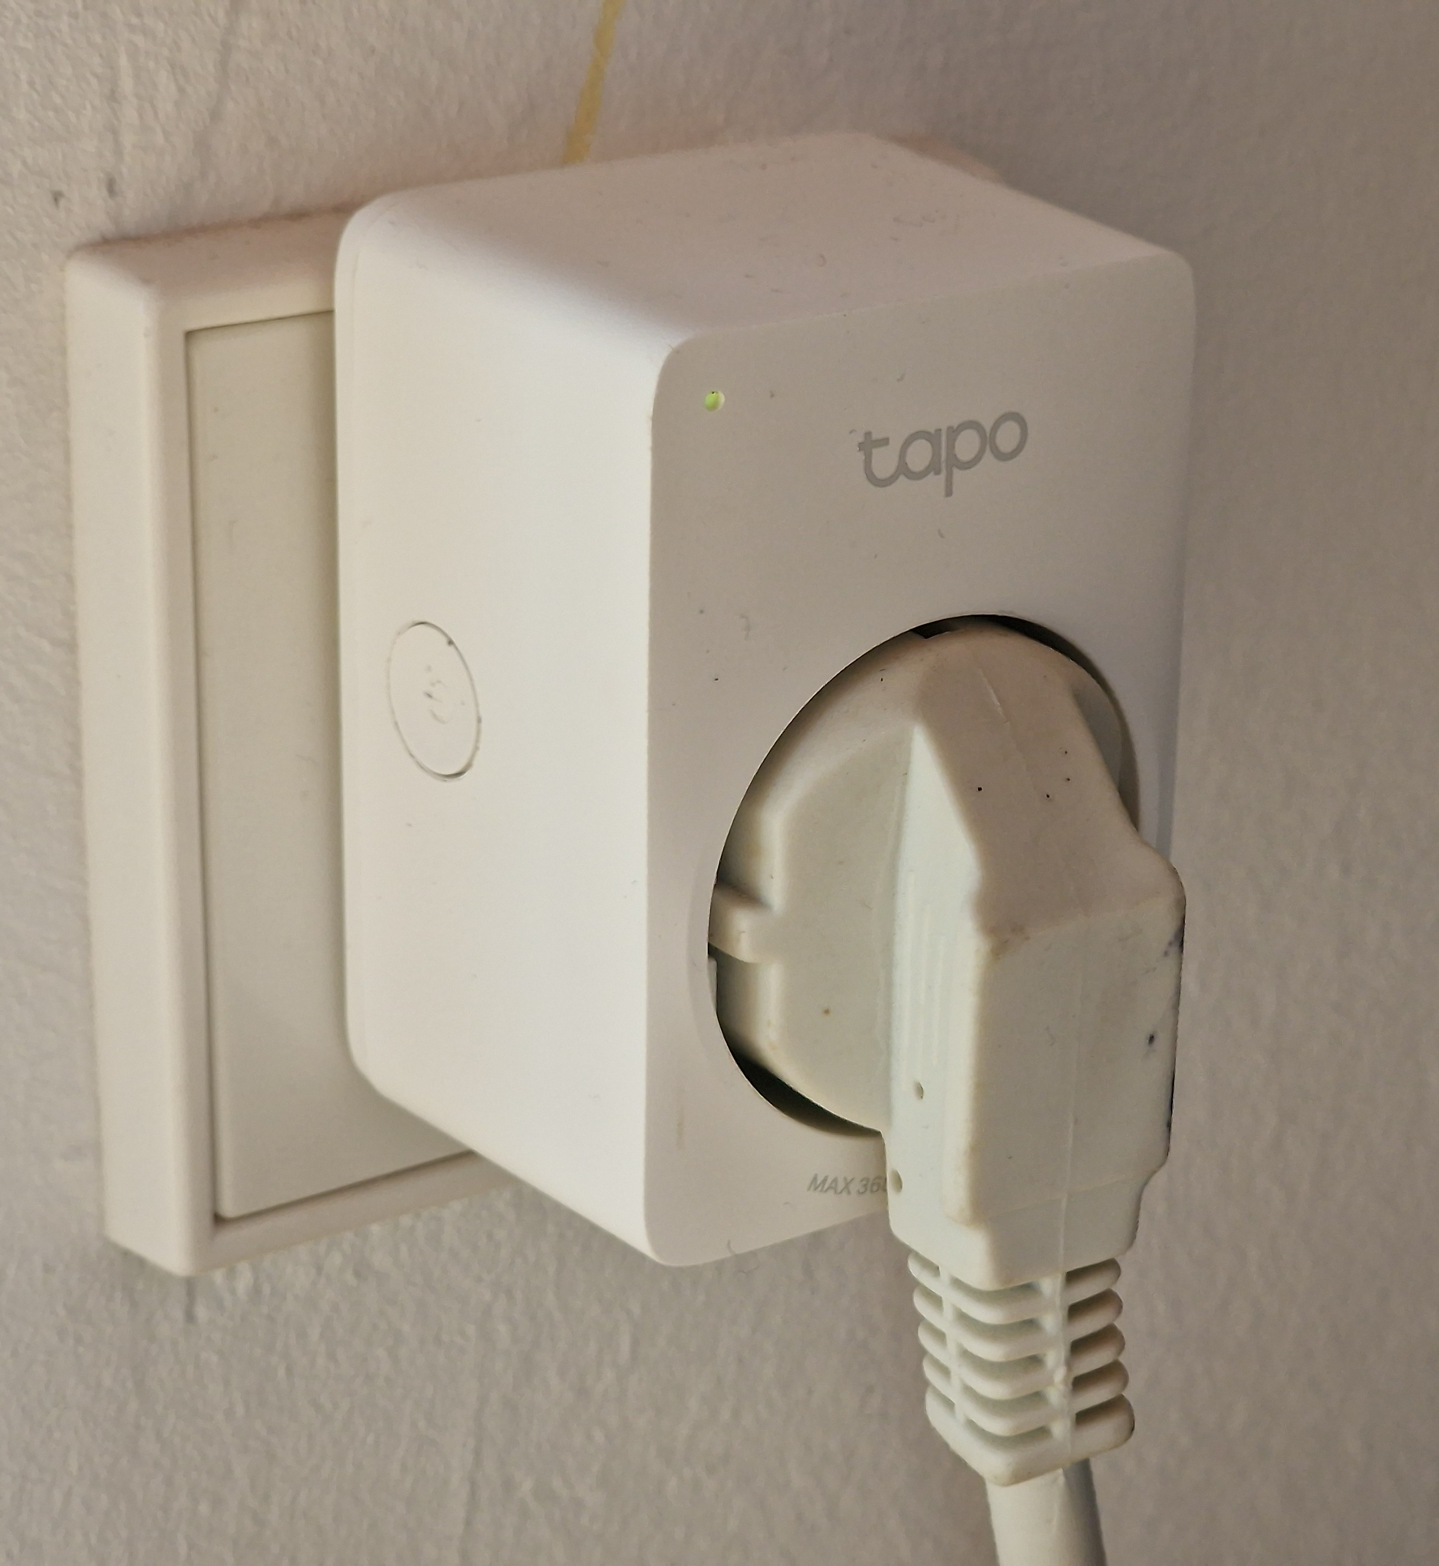  SmartHome socket © ZEBAU GmbH | 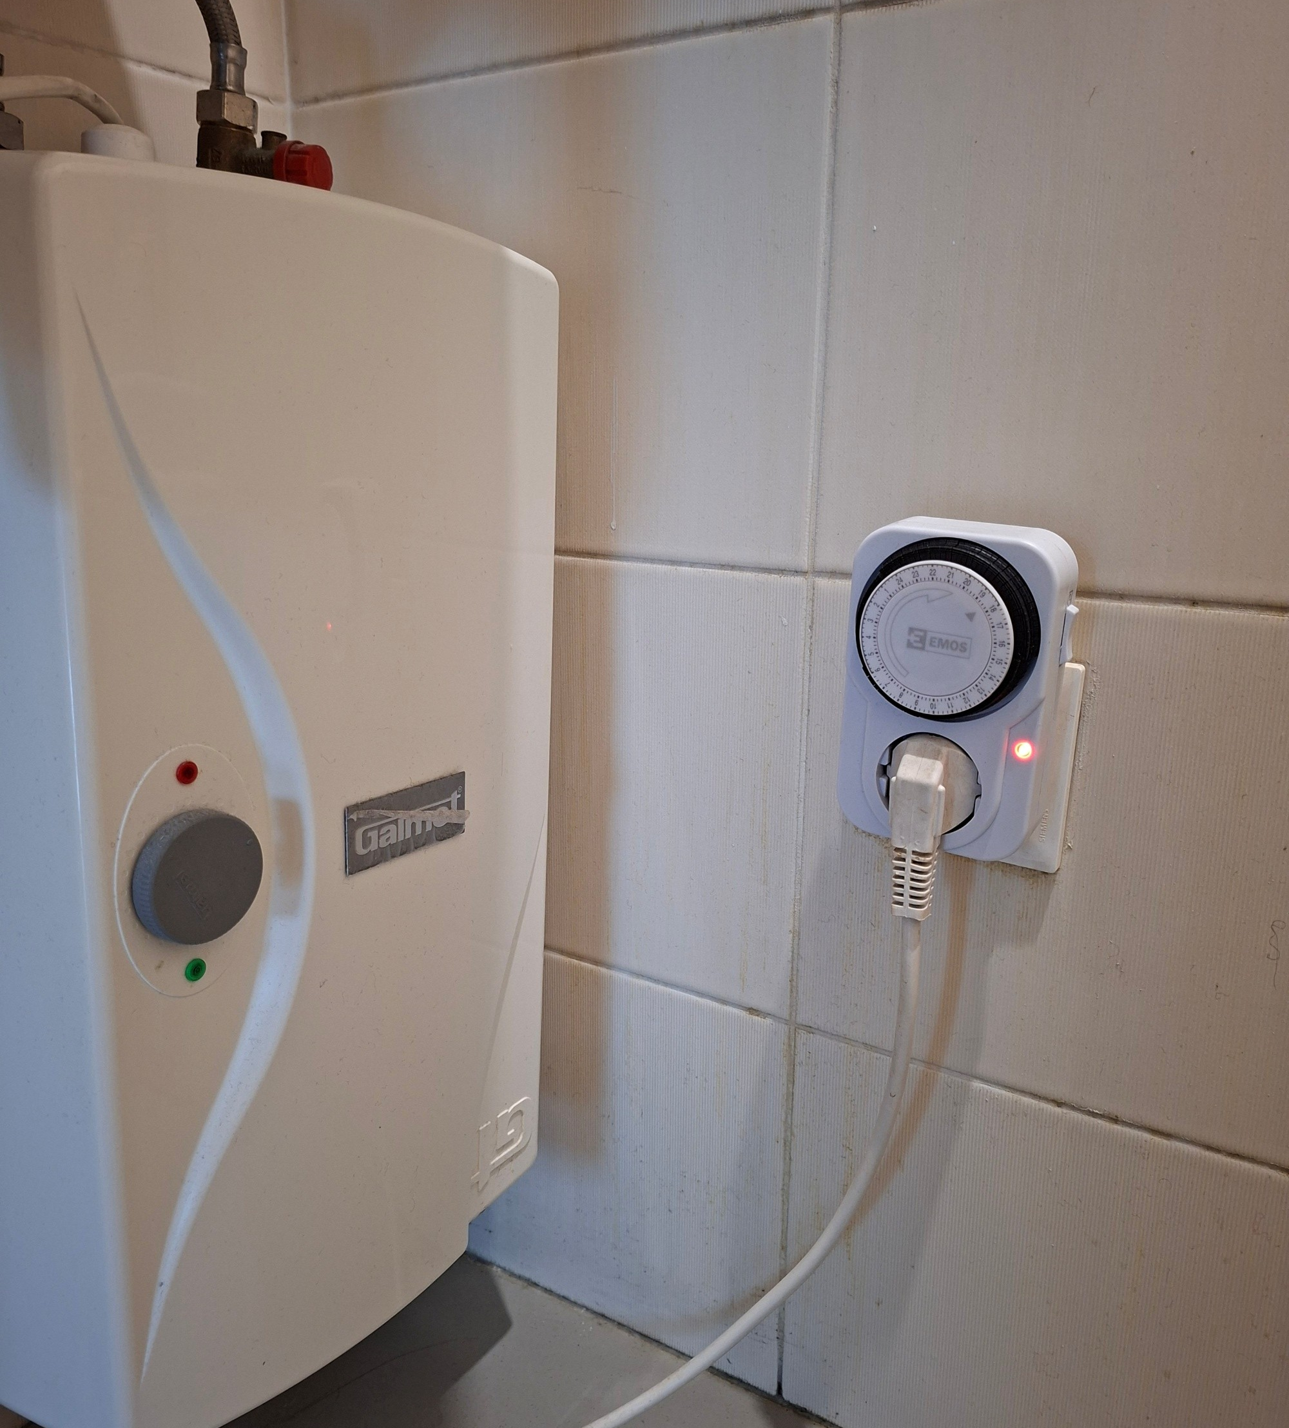  Socket with timer © Advertising company "Aukso vartai"

Aerator for water faucet
Brief description
Water consumption in offices is generally much lower than water consumption in households but can vary depending on the size of the office and the facilities there. The average water consumption in offices is usually between 2 and 5 litres per employee per day. Water consumption is higher in workplaces where people shower after work.
One of the simplest technical solutions for saving water is an aerator. This is a small, special device that is mounted on or inside the faucet. It distributes the water more widely, without reducing the water flow, so that water is used more efficiently, and less water is needed. Faucets with aerators can save up to 40 % of the water without the discomfort of washing process. Water flow adjustment function allows to increase or decrease the water flow at any time in the range of 2-6 litres per minute.
This solution also exists for shower heads.
Reduced water pressure saves water as well as electricity, which is needed to pump and store the water. The energy savings are particularly high if hot water can be saved as a result.
#aerator #watersaving #waterfaucet #perlator

Thematic allocation |  | Building categories
☐ Insulation | ☐ Electricity production | ☐ Administrative | ☐ Educational or social institution
☐ Energy/ heating system | ☐ Lighting | ☐ Commercial | ☐ Residential housing
☒ Warm water supply | ☐ | ☐ Industrial construction | ☒ All building types

Implementation time | Saving potential
☒ Quick to implement (within a few days) | ☒ Energy | ☒ Costs
☐ Short term (within 12 weeks) | ☐ CO₂ | up to 40 % of water
☐ Medium term (within 6 months) | ☒ Other positive Effect:
☐ Long term (longer than 12 months) | Less leaks

Orientation | Priority level | Qualification level | Special safety
☐ Behaviour | ☒ Low | ☒ DIY / own work | ☒ Not necessary
☒ Technical | ☐ Medium | ☐ Specialist company | ☐ Advisable
☐ Construction | ☐ High | ☐ Expert | ☐ Mandatory

Implementation requirements
Investment costs | Return of investment
The price of one aerator is from 2 – 12 €. | Minimal investment with quick return in 2-4 months. Cheap aerators save 15 % but more expensive ones can save up to 40 % of water.
Possible subsidies and programs | Availability of the material or technology
Example for Germany  Currently no German funding programs for this measure available.  Possible implementation within the framework of a funded measure of the program “Measures to Promote Climate-Friendly Drinking Water Supply” (“Maßnahmen zur Förderung klimafreundlicher Trinkwasserversorgung“ im Rahmen der sog. Kommunalrichtlinie der Nationalen Klimaschutzinitiative) | The aerator can be easily obtained; many options are available (including extra functions). Available in different sizes and dimensions. A rubber gasket is included.
Special requirements, safety precautions, challenges or conditions
The aerator is not recyclable.

Responsibilities / Actors
Mandatory actors and required competencies
---
Voluntary / helpful actors and competencies
---
Possible implementation partners
Janitor, maintenance personnel

Implementation process
First steps to initiate the measure:  preparatory actions | Installation instructions and guidelines, How to’s, open source initiatives
- Selecting the type of Aerator needed and purchase. | Example of installation process: https://www.energy.gov/sites/default/files/2023-10/24-2_Install-Low-Flow-Faucet-Aerator.pdf
Realization of the main part | Accompanying communication
- Unscrewing the standard nut from the faucet.
- Replacing it with a new device.
After installation of the measure: maintenance/operation routine | Further comments/ links
- Clean regularly with a toothbrush and lime remover. | Standard thread fits most taps on the market.  Ideal for kitchen and bathroom taps.

Photos if available
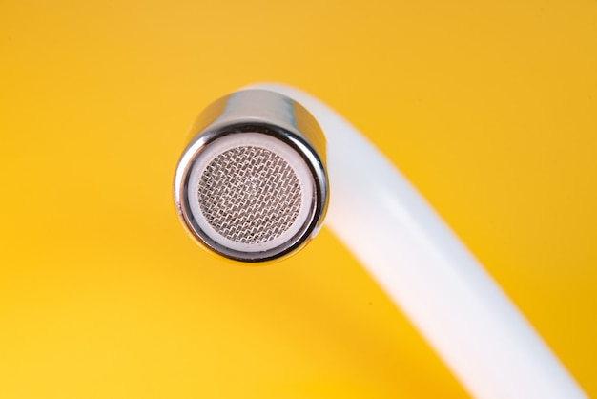
Faucet Aerator © designed by Magnific (www.magnific.com)

Sensor water faucet
Brief description
A sensor water faucet, also known as automatic or touchless faucet, uses sensors to detect the presence of hands or objects and automatically controls the flow of water. It typically features an infrared sensor located near the spout, which activates the water flow when it detects motion within its range. The water stops flowing once the motion is no longer detected, preventing water from running unnecessarily. Sensor water faucets are an efficient and practical solution for office environments, offering benefits in hygiene, water and energy conservation, and overall user convenience.
Preventing water from running saves water as a resource, as well as energy, which is needed to pump and store the water. The energy savings are particularly high if hot water can be saved as a result.
An additional water fitting option could be the installation of instantaneous water heaters on faucets. This could be especially useful in old buildings, where the whole retrofitting of pipes would be too costly or intrusive. This also reduces heat losses within the hot water system.
#sensor #automaticfaucet #watersaving #waterfaucet

Thematic allocation |  | Building categories
☐ Insulation | ☐ Electricity production | ☒ Administrative | ☒ Educational or social institution
☐ Energy/ heating system | ☐ Lighting | ☒ Commercial | ☐ Residential housing
☒ Warm water supply | ☐ | ☒ Industrial construction | ☐ All building types

Implementation time | Saving potential
☒ Quick to implement (within a few days) | ☒ Energy | ☒ Costs
☐ Short term (within 12 weeks) | ☐ CO₂
☐ Medium term (within 6 months) | ☒ Other positive Effect:
☐ Long term (longer than 12 months) | Hygiene and convenience through hands free

Orientation | Priority level | Qualification level | Special safety
☐ Behaviour | ☒ Low | ☒ DIY / own work | ☒ Not necessary
☒ Technical | ☐ Medium | ☒ Specialist company | ☐ Advisable
☐ Construction | ☐ High | ☐ Expert | ☐ Mandatory

Implementation requirements
Investment costs | Return of investment
A sensor water faucet is around 250 €.  An instantaneous water heater on the faucet costs 50 €. | The sensor faucets reduce water consumption by 40 % annually. The results are noticeable within the first few months.
Possible subsidies and programs | Availability of the material or technology
Example for Germany  Currently no German funding programs for this measure available.  Possible implementation within the framework of a funded measure of the program “Measures to Promote Climate-Friendly Drinking Water Supply” (“Maßnahmen zur Förderung klimafreundlicher Trinkwasserversorgung“ im Rahmen der sog. Kommunalrichtlinie der Nationalen Klimaschutzinitiative) | Sensor water faucets and instantaneous water heaters are widely available. They come with various models and features accessible to suit different needs and budgets. The materials can be recycled.
Special requirements, safety precautions, challenges or conditions
Sensors can malfunction due to power issues or sensor failure, leading to water wastage and user frustration. Better circuitry and alert systems could help mitigate these problems.

Responsibilities / Actors
Mandatory actors and required competencies
---
Voluntary / helpful actors and competencies
Plumbing company for installation if necessary
Possible implementation partners
Janitor, maintenance personnel

Implementation process
First steps to initiate the measure: Preparatory actions | Installation instructions and guidelines, How to’s, open source initiatives
- Purchasing of sensor faucets and instantaneous water heaters if applicable.  - Turning off water supply. | Example of installation process: https://www.youtube.com/watch?v=RSYvHsXV_XM
Realization of the main part | Accompanying communication
- Removing the Old Faucet (if applicable).  - Installation of the Sensor Faucet.  - Installation the Control Box and Sensor Components.  - Testing and Calibration to check for leaks and adjusting the sensors sensivity and range if necessary. If the faucet has temperature control, test and adjust the water temperature and flow rate. | If installing in an office or shared environment, inform users about how the sensor faucet operates and any specific features it has.
After installation of the measure: maintenance/operation routine | Further comments/ links
- Regular maintenance to ensure long operation.

Photos if available
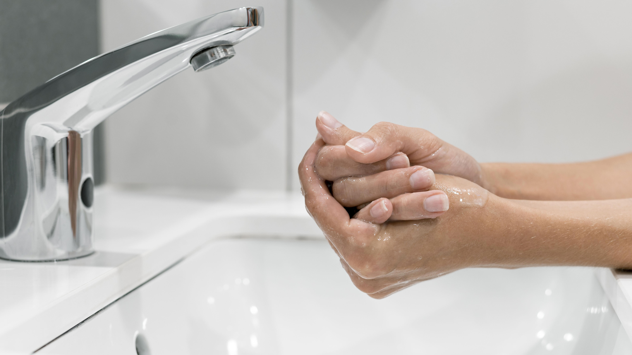
Sensor water faucet © designed by Magnific (www.magnific.com)

